version 25Apr2012-0030

Psychotherapy Data: Time Series Analysis

Bruce M. Small

York University

Author Note

Bruce M. Small, Department of Psychology, York University, Toronto Ontario
This paper is completed in fulfillment of the 4th year honours thesis requirement (PSYC4000) of the York University Honours B.Sc. Psychology Program, supervised by Prof. John Eastwood. The author also thanks Dr. R. Donald Small, Adjunct Professor of Mathematics, Carleton University, Ottawa, Ontario for his assistance in understanding the mathematical reference texts.
Correspondence concerning this thesis should be addressed to Bruce M. Small, Small & Rubin Ltd., 21 Carlton St., Unit 3407, Toronto ON M5B 1L3. E-mail: bruce@envirodesic.com.
Table of Contents
Abstract 3
Introduction 4
Thesis 5
Similarity to Changes in Other Fields 8
Use of Deep Characteristics and Mathematical Modeling 12
The Characterization and Analysis of Time Series (CATS) Method 16
Analysis of Time Series Data Using the Characterization Routine 21
Building Models for Therapy Using the Mathematical Model Generator 24
Discussion and Conclusions 29
Recommendations Regarding Multidisciplinary Context 30
Appendix A: Mathematics of Time Series in Psychotherapy 32
What Are We Trying to Do? 33
What Is a Time Series? 34
What Are Dynamical Systems? 39
Should We Use Statistics, or Statistical Dynamics? 44
Should We Use Mathematical Modeling? 47
What Is Linearity and Nonlinearity? 51
What Behaviours Are Common in Nonlinear Dynamical Systems? 57
How Do I Choose Order Parameters for a Dynamical System? 61
What Do I Need to Know About Stochastic Processes? 65
What Is Auto-Correlation? 67
How Do I Structure Equations to Model My Data? 69
How Are The Values in the Equations Turned Into Time Series? 74
Appendix B: Use of R for Calculation and Display of Time Series Analysis 76
Appendix C: Characterization Routine and Mathematical Model Generator 85
References 86
Abstract
The product of this thesis is a method that is designed to (a) automate the analysis of time series data from therapy sessions and (b) to create and verify mathematical models that would simulate therapy sessions. The Characterization and Analysis of Time Series (CATS) Method outlined herein can be used to help sort good sessions from bad sessions and to establish suitable coefficients for mathematical models of therapy sessions. The method was deliberately made content-neutral and can be tailored for different styles of therapy, for different ways of choosing deep characteristics of time series, and different ways of modeling therapeutic interactions with nonlinear equations. This work is based on the premise that tracking how therapy sessions unfold in time adds a new and richer dimension for examining therapeutic interventions than previously employed. It builds on the work of others who have demonstrated that nonlinear mathematical models can be created to simulate human interactions. The work documents efforts during the 2011/12 academic year to investigate the mathematical analysis of time series and structuring of mathematical models involving coupled nonlinear equations. There is considerable further work that will need to be done by others before the method is complete. The thesis also includes a mathematical handbook for students who wish to study the dynamics of psychotherapy, and for others who may intend to move this work along further in the future. This effort, if pursued, holds the promise of automating data analysis from psychotherapy sessions and making it easier to assess and alter therapeutic interventions. This preliminary work suggests that mathematical models may be useful for exploring changes in therapies and in establishing useful deep characteristics of psychotherapy time series, that might in turn be helpful in categorizing sessions. One conclusion from the research is that psychotherapy time series research would benefit from interdisciplinary collaboration particularly with respect to mathematics.

Psychotherapy Data: Time Series Analysis
This thesis is structured in several parts. The main body of the document describes the primary product of the year's work: description of a method for automating the analysis of psychological time series data obtained from actual therapy sessions, and for generating matching mathematical models that might help in advancing knowledge about therapy. The bulk of the effort of the year's work, however, went into understanding how and why to deal with time series data in the first place. This aspect is represented by Appendix A, which is a brief handbook designed to help others who may wish to follow this path. In it I have posed and answered a number of basic questions about the mathematics of time series, in simple language. The computer work required to develop and implement the method described in the main body of this document was also a challenge, partly because of the cryptic nature of the documentation of the R programming language that I used. As a result, I have included Appendix B to reveal exactly why and how R was used to create the programs and calculations illustrated herein. It is my hope that others can save time by examining and borrowing those aspects of the computer routines that may be useful to their own work. Should any reader wish to acquire the electronic copy of this document and associated diagrams and R programs for their own use in study or research, they are invited to download them at http://www.envirodesic.com/york/thesis.html.
I would also like to note that this work represents only what could be done within the limits of the 2011/2012 academic year. This document makes no pretense of being comprehensive or at sufficient depth of analysis for others to use it or extend it without further background work. As such it documents clearly the journey undertaken, but must necessarily fall short of a full prescription for the process of analyzing time series in psychotherapy.
Thesis
This investigation began with a seemingly simple question. The question arose from the generation of data from a videotape of a session with a therapist and client. Trained observers estimated a number of parameters based on what they saw at fixed time intervals (Eastwood & Gaskovski, 2010). The data resulting is a time series – that is, a set of values of each parameter at successive points in time. If the values are plotted on a graph showing the parameter measure on the vertical axis, and increments of time on the horizontal axis, and the points are joined by lines to make the changes in the parameters more visible, each parameter yields some kind of wiggly line like that shown in Figure 1 below:
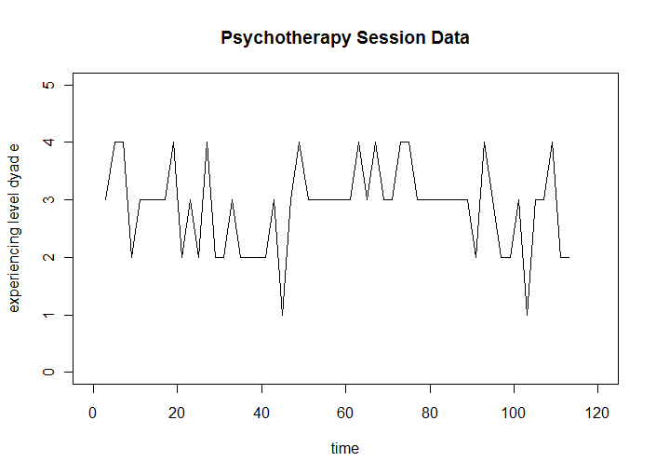
Figure 1: Sample times series data from a psychotherapy session. This graph is typical of what a time series looks like in psychotherapy. It is made up of coded data extracted from a video record of an actual therapy session.
Then the simple question was asked: “What can we do with this data?” That question led to other questions, such as: “What can this data tell us about the phenomenon we are studying?”; “Can we apply statistics to this data?”; “Can we approximate this data with lines and curves?”; “What kind of mathematics must we know to make sense of this data?”; “Can we simplify this data to make conclusions from it?” and many others.
The question, of course, turned out not to be as simple as it first appeared. It does, however, still represent the core objective of this investigation, that is, to determine what we can justifiably do with time series data derived from the human interactions that we would find in a psychotherapy session. Knowing what we can do with this data requires a solid understanding of (1) what the data represent, (2) what we want to know about the system we are studying, and (3) the meaning of the mathematics that we intend to apply. The question is not simple, because these three understandings are inter-related. For example, what we can ask about our system will depend on the data we choose to collect, and on the mathematics we use. Which mathematics we use will depend on what data we collected and what we already know about our system. And what the mathematics means and reveals about our system will affect what data we want to collect next.
Covering all three understandings above is beyond the scope of this investigation. The first two understandings belong rightfully in the domain of the principal investigators of the psychological phenomenon in question (that is, a session between a therapist and client), which is described more fully by Eastwood and Gaskovski (2010). The third understanding is the intended contribution of this particular investigation: the specification of the kind of mathematics that can and should be applied to such psychotherapy time series, and the elaboration of its meaning. Because the three understandings are inter-related, this investigation represents one input to the effort of answering “What can we do with this data?”, but its results will require consideration by others within their research, before the question can be fully addressed.
The thesis of this investigation is therefore to prove or disprove the following hypotheses: (1) there are specific mathematical methods that can be applied to this kind of psychotherapy time series data; (2) there are ways of deciding which methods should be applied to this kind of data; and (3) there are meanings that accompany the use of these mathematical methods that may help to guide other aspects of the research into psychotherapy.
Also of background interest is the question as to whether producing time-based observational psychotherapy data within sessions and analyzing the resulting time series can yield additional viewpoints that are not accessible by more traditional ways of assessing therapies. Gottman, Murray, Swanson, Tyson & Swanson (2005) suggest that several difficulties that are associated with such observational data have deterred many researchers from embarking on the process: (a) it is costly to make video records of sessions and to spend time generating numbers from them, (b) it takes a great deal of time and experience to develop a good coding system based on sound hypotheses, and ( c) “inter-observer reliability drift and decay” must be addressed as an ongoing problem (p. 11). Whether or not this process is worthwhile depends a great deal on what happens next. If the steps that follow are mathematically sound and robust in the extraction of knowledge about psychotherapy from the raw data, the effort of recording and coding is more justified than if the followup is weak.
This suggests a fourth hypothesis which also guided this work: (4) it is possible to produce and describe a generic method that could guide researchers in their use of observational psychotherapy data. The verification of this hypothesis is shown in Figure 2 later in this paper.

Similarity to Changes in Other Fields
One perspective that proved useful in this investigation was to note that generating time series data from psychotherapy sessions represents a departure from the predominant mode of investigation in empirical psychology currently, even though time-based observational data in areas like marital theory stem back to the 1970s and early work in developmental psychology also pointed to “interaction as a process in which sequences of behavior unfold in time” (Gottman et al., 2005, p. 13-14). Time-based observations do not, for example, resemble the choosing of a random sample from a population and the generation of data from evaluation of responses before and after changing one environmental parameter, while holding others constant. Rather than being a “snapshot” of a random group's collective performance under strict experimental conditions at one or at most a few given times, observation of actual psychotherapy is (literally) a video of an ongoing performance of a complex task by two specific human beings, interacting together and affecting each other throughout the task. That video is reduced to numbers by extracting from it the values of certain defined parameters such as client affect (Eastwood and Gaskovski, 2010). Because it represents a departure from the predominant method of investigation, we can expect that the best methods for analyzing its result may be different from the predominant ones as well.
Nowak, Vallacher and Lewenstein (1994) suggest that a fundamental shift in psychology is necessary. Rather than looking for one-way cause-and-effect relations between variables, psychology should be looking for “regularities or patterns” (p.282). Vallacher and Nowak (1994b) also suggest that looking at complex systems at only one point in time is “informationally impoverished” (p. 10). While distinct causes with specific effects are one kind of pattern, variables in dynamical systems can be both cause and effect at the same time, because “the time evolution of each variable is determined by values of other variables in the system” (Nowak, Vallacher and Lewenstein, 1994, p. 282). Vallacher and Nowak (1994b) note that some have called for abandoning a scientific approach because of the complexity of human behaviour and of the indeterminate effect of human free will on the outcome of any interaction. They take the opposite approach, namely that “explicit attention to this complexity and seeming indeterminism of human behavior should enable theorists and researchers to capture the dynamics of social psychological phenomena” (p. 7). Thus the debate is between the continuation of emphasis on one-way causation between variables at specific points in time, or a shift in emphasis toward system dynamics, where all variables are expected to be related to one another in both directions over time through complex feedback.
Fortunately, many fields have undergone similar transitions, and it is likely true that in nature, “virtually every phenomenon can be understood as a complex system” (Vallacher and Nowak, 1994b, p. 8). In each case, mathematics have been developed and improved for dealing with the new ways of looking at the phenomena being studied. Time series data have been generated and analyzed in many fields, and an extensive literature now exists on the mathematical treatment of time series. Some of the early beginnings of this are discussed in Norbert Wiener's book Cybernetics, written in 1948 and revised in 1961, which describes a new field encompassing “control and communication theory, whether in the machine or in the animal” (1961, p. 11). Wiener and his colleagues were interested in both the design and the mathematical modeling of systems, whether mechanical devices, computational machines or living things, that used feedback to govern their output. With remarkable foresight, Weiner predicted many aspects of today's computer world and its applications, including monitoring and control of everyday activities in a multitude of fields from rehabilitation medicine to industrial production. Wiener also speculated about the application of cybernetics and time series analysis to human social situations:
It is certainly true that the social system is an organization like the individual, that is bound together by a system of communication, and that it has a dynamics in which circular processes of a feedback nature play an important part. (p. 24).
Wiener cautioned, however, not to expect the kind of success in social science that has been achieved in the natural sciences, because we can't be sure “that a considerable part of what we observe is not an artifact of our own creation” and because “we are too much in tune with the objects of our investigation to be good probes” (p. 164). These cautions are well taken, but have not prevented psychology from beginning to follow in the footsteps of cybernetics and many other fields, to analyze the dynamics of systems, in this case human systems, and attempt to model them in mathematical terms.
Psychology may be at an early stage of changes that other fields have already been through. For example, Wiener (1961) describes the early days of electric circuit theory wherein the mathematics didn't go beyond “linear juxtapositions of resistances, capacities and inductances”. Yet when newer apparatus was developed (e.g. amplifiers, voltage limiters and rectifiers), the use of nonlinear mathematics became essential. For a while, many attempts were made to “extend the linear notions of electrical engineering” but this was not sufficient (p.viii). Likewise, classical mechanics was familiar with deterministic systems, in which the state of a body at every point in time was precisely determined and the behaviour of the system could be predicted precisely into the future. But stochastic (randomly varying) phenomena, statistical mechanics of fluids, and ultimately quantum mechanics introduced the necessity of dealing with random fluctuations and the idea that a system could not be precisely predicted into the future. Contemporary fields as diverse as climatology (weather conditions), biology (the immune system), ecology (predator-prey relations), chemistry (auto-catalytic reactions), physics (lasers), cosmology (galactic evolution), epidemiology (the spread of viruses), and economics (economic cycles) have all embraced the analysis of time series for their particular purposes, including stochastic and nonlinear mathematical modeling of dynamical physical or social systems (Vallacher and Nowak, 1994b, p. 8 & Nowak & Lewenstein, 1994, p. 18). Vallacher and Nowak (1994b) emphasize the difference between a deterministic approach and a systems perspective:
In the traditional model, it is assumed that specific factors can be isolated from one another and examined for their independent contributions to the phenomenon of interest. The systems perspective, in contrast, emphasizes the feedback among the relevant factors and the tendency of the system to become self-organized on the basis of patterns of such feedback. On this view, variations in any one factor are related in a nonlinear fashion to the behavior of the system as a whole; even a miniscule change in a given system element can, by virtue of its interactive feedback with other elements, promote dramatic, even qualitative changes in the functioning of the entire system. (pp. 8-9)
Why is this focus on time series in psychology relatively recent? Even thirty years ago, Gregson (1983) asked:
Given that psychology aspires to be rigorous and quantified in many areas and given that all behaviour and human experience exists in time and creates sequences in time why have psychologists been relatively ineffective and unoriginal in their contributions to the concepts and methods that are available for the analysis of series of events? (p. 141)
He concludes: “If psychology is a science about dynamic processes, then it is empirically about systems and about time series. That much is inescapable.” (p. 413)
The challenge of this current investigation is to select from the existing literature in appropriate fields, including the mathematics of time series, beginning points for clinical psychology researchers who are becoming serious about time series analysis. The goal is to assemble enough of the necessary mathematics in a sufficiently clear form to enable clinical researchers to grasp the full meanings and implications of mathematical analysis and modeling of the dynamic human systems they are interested in, e.g. a psychotherapist and client in session.
Use of Deep Characteristics and Mathematical Modeling
Sessions between therapists and clients are examples of nonlinear dynamical systems. They are highly unpredictable and may exhibit many differences in behaviour both within a session and between one session and the next. The client's behaviour and the therapist's behaviour may be closely coupled, and each may alter their behaviour not only in the moment but as a function of their own and the other's behaviour previously in the same session and in previous sessions. Each may also be subject to random fluctuations in how they feel and how they perform, for a myriad of reasons. Notwithstanding, it is helpful to be able to grasp whether there are deep characteristics of such a system that are identifiable and stable despite this seemingly limitless variability. Mandell and Selz (1994) describe these as “the persistent, statistical, dynamic properties of the system that withstand its time-dependent, unpredictable details” (p. 57).
This approach has been used by Eastwood and Gaskovski (2010) in analyzing time series from actual psychotherapy sessions. They formulated both temporal and non-temporal hypotheses about client-therapist interactions in two sessions that were known to be “good” sessions (high client-therapist alliance in a post-session questionnaire and good overall therapy outcome) and two sessions known to be “bad sessions” (low client-therapist alliance in a post-session questionnaire and poor overall therapy outcome). They extracted and analyzed client affect and client-therapist alliance measures from videotapes of these sessions, in order to test their hypotheses and learn more about what characteristics of client-therapist interaction over the period of a session might help to predict either good or bad sessions. Knowing the potential variability in client-therapist interactions, they were seeking measures that would characterize these dyadic systems of two individuals overall in terms of potential success, notwithstanding the variability in the detail from one session to another. Their non-temporal hypothesis (independent of order in time) was that good outcome clients would show more affect that was directed towards themselves, and less directed towards the therapist, than poor outcome clients would have. Their temporal hypothesis was that good outcome clients would show broad sequences of positive-negative-positive (PNP) affect directed towards themselves over the time span of a session, consistent with exploring feelings associated with problem issues within the session. Their analysis of time series data from their research confirmed these hypotheses (as illustrated in Figure 2 following) and also pointed the way to assessing several additional characteristics that might also be predictive of outcome, including the presence of smaller PNP patterns (over much shorter periods of time within the sessions) and the stickiness or inertia of the client's affect direction (tendency to be similar to the last measurement).
Eastwood and Gaskovski's (2010) data revealed, for example, that poor outcome clients were much more likely to become stuck in negative affective responses to their therapists. Gottman et al. (2005) also discussed the concept of inertia in the context of marital relationships, and showed that distressed couples exhibited more rigidity and inertia than nondistressed couples (p. 15). In particular, negative states become “an absorbing state for dissatisfied couples”. And once that state is entered, it is hard to exit (p. 17). Gottman et al. (2005) define emotional inertia as the “person's tendency to remain in the same emotional state for a period of time” (p. 130).
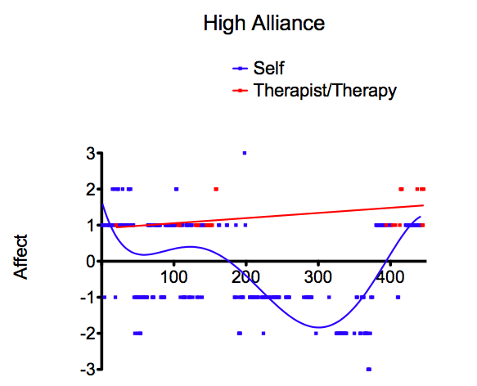
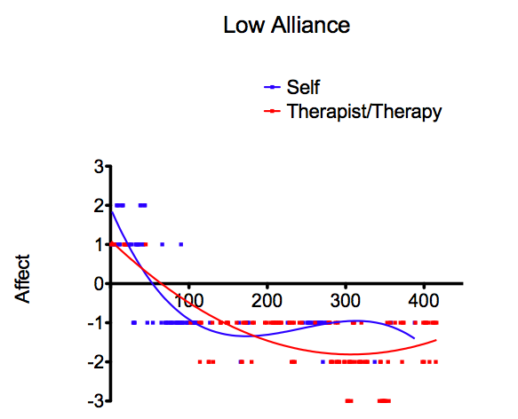

Figure 2: Affect toward self and therapist during high and low alliance sessions. These graphs demonstrate the curve shapes for high and low alliance sessions. The client's affect toward self in the high alliance (good) session follows a PNP (positive-negative-positive) pattern represented by the blue curve on the left, while that of the client in the low alliance (bad) session declines from positive and remains negative, as shown in the blue curve on the right. In the high alliance session the client's affect toward the therapist is positive, as shown in red, and in the low alliance session the red curve showing the client's affect toward the therapist becomes negative. From Eastwood and Gaskovski (2010).

The deep characteristics that the system under study may exhibit will vary depending on the variables chosen to measure and therefore characterize the state of the system. Choosing these order parameters, or global variables, is important not only for investigating effects that the researcher is most interested in, but also for the possibility of modeling the system mathematically with coupled sets of equations (Nowak and Lewenstein, 1994, p. 20). The purpose of modeling interactive human systems is to gain some insight into the dynamics of the system under study, in such a way as to be able to verify whether the dynamics hypothesized in such a model can produce data similar to actual therapy sessions, and to be able to vary the parameters within such a model to enable predictions of actual behaviour under different conditions.
Of course it might not be possible to know which variables will prove fruitful, until such a quantity is assessed. Accumulating a repertoire of quantities that are important to assess is necessarily an iterative process, with some quantities being retained in the analysis because they prove to be predictive of good short or long term results, and some dropped as being irrelevant to such concerns. In the process of choosing appropriate quantities for assessment, theories are inherently generated, whether explicitly stated or not, and these theories in turn affect what additional quantities are chosen for assessment and verification of their connecton to outcomes. Gottman et al. (2005) express some despair at the number of hypothetical connections that have been made between marital characteristics and success in marriage, that have not been verified empirically but nonetheless have affected marital therapy. They propose that an effort must be made to empirically find the “correlates” and “predictors” of stability and satisfaction in marriage (p. 21). Their caution underscores the importance of creating a process for not only choosing quantities for assessment in observing psychotherapy sessions, but for proving over time that they are indeed the most useful quantities to assess. Eastwood and Gaskovski (2010) indicate that they found it necessary after their first investigation to revise the coding scheme that operationalized one of their primary variables (client affect). The generic method of dealing with time series data that is outlined in the following section is therefore deliberately a dynamic one ⎯ it involves iterations and feedback loops rather than a unidirectional approach that gets applied only once, so that over time, modifications can be made in the order parameters used, the deep characteristics being calculated, and the ways the mathematical model equations are structured.
The Characterization and Analysis of Time Series (CATS) Method
Figure 3 following portrays the substantial result of this thesis, which is the elaboration of a procedure for automating the characterization and analysis of actual therapy sessions through the use of time series data, and for creating mathematical models that will generate similar time series data for comparison. The computer routines filter and tweak the mathematical models until they bear similarity to the actual data, particularly in its deep characteristics that are more independent of the potential fluctuations involved in coupled multiple time series models that also contain stochastic (random) components.
The Characterization and Analysis of Time Series (CATS) Method is built on work done by Eastwood and Gaskovski (2010) with actual therapy session data, but it is designed to represent a generic process that is suitable for application to other forms of therapy and other systems of coding therapeutic variables. The part of the process dealing with actual therapy sessions is highlighted in yellow on the upper left part of the diagram shown in Figure 3. The initial and final focus of the CATS method is a therapist-client dyad. Therapy sessions are conducted in the whatever mode of psychotherapy is under investigation. Sessions are video-recorded for future analysis and if necessary, subsequent re-analysis with different coding systems. Each session is coded by trained observers to produce time series data representing the unfolding of various markers of interest at consistent time intervals throughout the session (symbolized by the pale yellow box at the centre top of Figure 3).
In the initial research into characterization of this kind of time series data from actual therapy sessions, independent evaluations were made to decide whether a given session and its time series data represented a “good” session or a “bad” session (Eastwood & Gaskovski, 2010).
this space is reserved for Figure 3
The researchers then explored a multiplicity of time-independent measures that could be determined from the resultant series, including the general shape of the curves produced, to provide a quantitative determination as to which of these time-independent characteristics might help to distinguish between “good” and “bad” sessions.
The CATS method introduces (in the large central blue box in Figure 3) a computer routine (in R, a language for processing data and statistics) that automates the characterization of the time series from actual sessions, revealing values for the same characteristics that were explored in the initial research. This Characterization Routine can be expanded to include any number of so-called deep characteristics, and any statistical evaluation preferred for analyzing correlations among the characteristics, as well as correlations with any external measurements that were done to assess the degree of success of the therapy session. The fully characterized session data and analysis (represented by the smaller pale yellow rectangle labeled “Characterized Session Data” in Figure 3) can then be used in three ways: (a) to inspire the addition of additional deep characteristics, (b) to inspire changes or additions to the coding procedures and variables coded for in the review of future video recordings of sessions, and (c) to inform and instruct both the researchers and other therapists on ways of recognizing that sessions are proceeding well or poorly. These connections are reflected by the broad blue arrow extending from the lower pale yellow box to other boxes above and to the left in Figure 3.
The computer routine that characterizes and analyzes the time series data from actual sessions really cannot discriminate as to whether the time series came from an actual session, or a simulated session. It opens the door, then, to include simulated time series data produced by simple mathematical models that, at least in theory, portray some very specific aspect of the therapeutic dyad. As part of the CATS method, an additional computer routine was created to take coupled nonlinear equations representing the chosen coding variables, and recursively calculate their resulting values at successive times. This computer program produces multivariate time series of the same length as those produced from the actual therapy sessions. This is shown as a blue box on the upper right of Figure 3, labeled “Mathematical Model Generator Routine,” which in turn points to a pale green rectangle to its left representing the resulting time series data.
Similarly to the time series from actual sessions, these time series are provided to the Characterization Routine (central blue box in Figure 3) to assess the same deep characteristics as were assessed for the data from actual therapy sessions. The pale green square below the blue Characterization Routine represents the analyzed simulated time series data from the mathematical model, parallel to that of the analyzed time series data for actual sessions.
On the mathematical modeling side (right hand side) of the diagram in Figure 3, between the blue Characterization Routine (central blue box) and its output from the mathematical model (the pale green square labeled “Characterized Model Data”) is a bifurcated arrow that leads to the right and ultimately back through the wider blue arrow to the blue Mathematical Model Generator Routine (blue box at upper right). These arrows indicates that the Characterization Routine is capable of rejecting outputs from the Mathematical Model Generator Routine if their time series characteristics do not conform to norms applied within the Characterization Routine. This allows the Mathematical Model Generator Routine to run in an iterative mode, altering any complex set of equation term coefficients in an organized manner and producing a long succession of time series trials for the Characterization Routine to check. This makes the development of mathematical models easier because the computer does a great deal of the work in determining appropriate coefficients for each term in the coupled nonlinear equations that form the mathematical models.
A third computer routine (yet to be developed) is shown beneath the pale yellow and pale green boxes in the middle of the diagram in Figure 3, in order to compare the characterized model data (from a single time series or a family of time series) to the characterized session data (either singly or as a family of time series) and assign a measure of the degree of fit. Depending on the criterion that would be applied within this Fitting Routine, the mathematical models would be further weeded out in favour of best-fit or better-fit models. The result is a shortlist of mathematical models (represented in the pale green box labeled “Shortlist” near the bottom right of the diagram in Figure 3), each being a set of multiple coupled equations simulating the evolution in time of the therapy variables of interest. These models and their resultant time series will bear some resemblance, at the very least in their deep characteristics, to the kinds of time series produced from the actual therapy sessions.
The final computer routine (also to be developed in future) shown as the blue rectangle at the extreme bottom right of the diagram in Figure 3 allows for the further manipulation of coefficients and terms in the set of plausible and useful mathematical models, preferably one at a time. In doing so, the researcher is asking “what if's” of his or her mathematical model. For example, he or she could ask “How would the session change if the therapist became more alert and attentive when the client becomes more negatively emotional?” and change coefficients and equation terms accordingly. The output time series could, in theory, give the researcher some insight as to how different factors could affect the outcome of the sessions. The therapist and researcher can together discuss the implications of the model's predictions, and in turn design experimental therapy sessions that will try different interventions in the actual therapy that might not otherwise have been thought of. The researcher may also use the predictions and questions that were raised by playing with the mathematical model, to alter or extend the coding of therapeutic variables of interest (shown in the yellow box at the top left of the diagram in Figure 3), and the characteristics of the sessions that will be evaluated and analyzed in the Characterization Routine (in the central blue box in Figure 3). The blue arrows extending left and upwards to the right respectively from the Manipulation Routine (blue box, bottom right) represent the feedback potential for using the output from the selected mathematical models to inform changes (i) in the actual therapy sessions, (ii) in the coding of actual sessions, (iii) in the choice of deep characteristics to be evaluated in the Characterization Routine, and (iv) in the choice of terms and coefficients in the Mathematical Model Generator Routine.
Implicit in the concept of the Manipulation Routine is a detailed study of the behaviour of any mathematical model produced, to understand what it does, how stable it is, what it would mean about actual therapy if it has any truth to it, and so on. Some aspects of this kind of analysis are discussed in Appendix A of Gottman et al. (2005, pp 361-363). A full understanding of how to produce mathematical models and how to analyze those that look promising is a subject in itself and psychology researchers wishing to attempt it would benefit from collaboration with others who are fully familiar with the process.
Analysis of Time Series Data in Psychotherapy using the Characterization Routine
The Characterization Routine (central blue box in Figure 3 and also expanded in Figure 4 following) is designed to operate on time series data either originating in actual therapy sessions (through coding of video recordings) or produced by mathematical models of therapy sessions in the Mathematical Model Generator Routine (upper right blue box in Figure 3). The purpose of the Characterization Routine is to automate the calculation of deep characteristics of either the actual client-therapist dyad, or the mathematical model of such a dyad.

This space is reserved for Figure 4
The components of the Characterization Routine are portrayed in the diagram shown in Figure 4. The computer program and its present subroutines are presented in detail in Appendix C and are downloadable from the website http://www.envirodesic.com/york/thesis.html. The concept of the Characterization Routine as well as its realization as a computer program are designed to be independent of the specific choice of coding variables, deep characteristics, and format of modeling equations. The only customization required to the basic program is specification of the name of the input data file and matching of the number and type of variables in the time series to the designated variables within the initial part of the program. Specific deep characteristics are handled in a series of subroutines (as shown on Figure 4), and theoretically there is no particular limit to the types of calculations that can be done to explore deep characteristics. It is important to note that there are entire scientific and mathematical fields devoted to the “signatures of nonlinear behaviour” for dynamical systems (Nowak and Lewenstein, 1994, p. 42). These are beyond the scope of the present investigation, but they are very rich in concepts and system behaviours that could be used as deep characteristics for investigating time series data in psychology.
In the current version of the Characterization Routine, there is not yet any statistical assessment of the correlation between the deep characteristics and the psychotherapy session ratings (as good or bad), but this feature could be added as an additional subroutine that can be called by the each deep characteristic subroutine. An output subroutine controls the format of the output, or characterization, of the time series. When the Characterization Routine is coupled in an iterative mode with the Mathematical Model Generator Routine, the deep characteristic subroutines are harnessed by the Model Generator to tell it what the corresponding measures of the same deep characteristics are for the output time series produced by a particular set of equations and equation coefficients. If they do not conform sufficiently to standards or ranges specified for the purpose of weeding out unsuitable equations, then the output time series is abandoned, and the model generator chooses another set of coefficients before recalculating a modeled time series and reassessing its deep characteristics.
The first deep characteristic subroutine peruses the values of the client time series with which it is presented and decides how to categorize the general shape of the time series curve over the time period of the session. Using Eastwood and Gaskovski's (2010) concept of a positive-negative-positive (PNP) client affect sequence as a base for a good session, the current computer subroutine checks for any of eighteen possible curve shapes that might conceivably be divided among good and bad sessions. A subset of these are portrayed in Figure 5 following, but have only been temporarily classified for illustrative purposes, since that will require further research and session analysis to determine the predictive value of each curve shape in terms of session outcome. A second characterization subroutine, shown in Appendix C, peruses the time series with which it is presented and calculates a value for the stickiness of the client affect state.
Building a Mathematical Model for Therapy using the Mathematical Model Generator
The Mathematical Model Generator Routine shown as the blue box at the top right of Figure 2 and expanded in Figure 6 following is designed to (a) calculate a time series from coupled equations specified within it, (b) submit the resulting time series to the Characterization Routine for analysis, and ( c) continue testing additional equation coefficients to generate acceptable versions of the mathematical model. As with the Characterization Routine, the Mathematical Model Generator Routine is designed at least in concept to be relatively generic. Alterations in subroutines specifying equation components allow for different ways of structuring the model equations. Alterations in the part of the routine that causes the Generator
This space is reserved for Figure 5
This space is reserved for Figure 6
to calculate successive versions of the equations (by changing coefficients of all the terms) will change the amount of exploration the Generator will do in its search for acceptable models. And as mentioned before, alterations in the Characterization routine that the Generator couples with, will change the criteria by which equations are judged in order to be declared to be a successful model.
The components of the Mathematical Model Generator Routine are portrayed in Figure 6. Sample output from the Generator is shown in Figure 7 following. The choice of equation terms for the program version included with this document are discussed within Appendix A following under the Section “How Do I Structure Equations to Model My Data?” The computer program itself and its subroutines are presented in more detail in Appendix C and are downloadable from the website http://www.envirodesic.com/york/thesis.html.

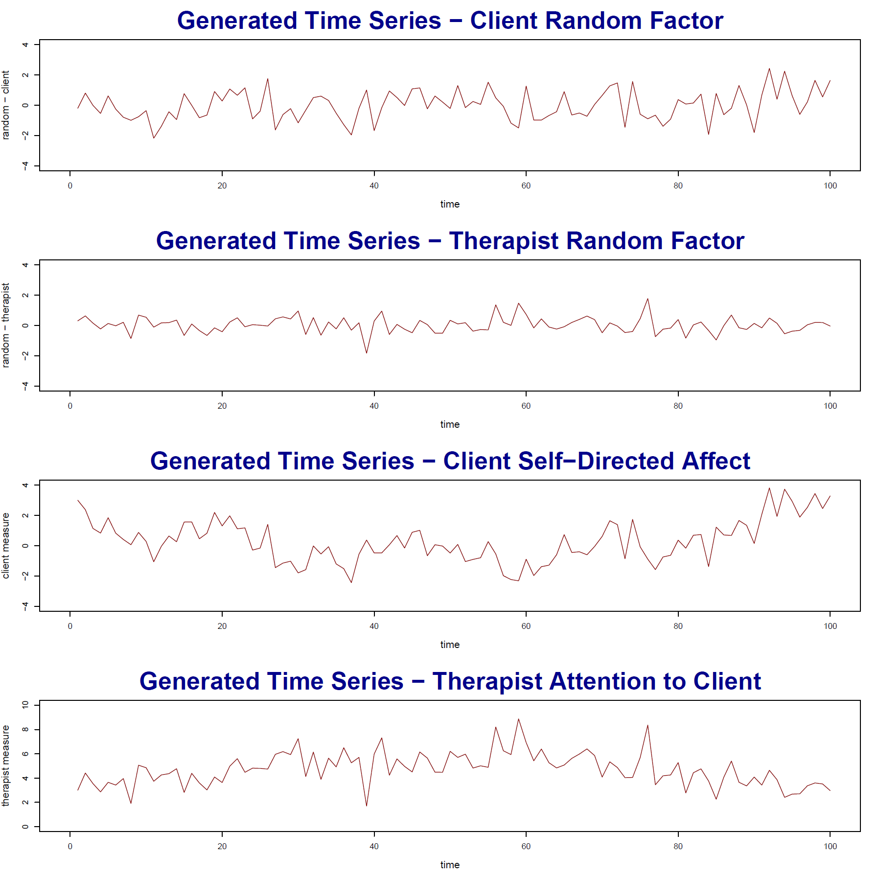

Figure 7: Sample output from the Mathematical Model Generator Routine. The top two series represent the random function for client and therapist, and the bottom two represent the total client and therapist measures. The therapist pays more attention as the client explores issues and shows negative affect.
Discussion and Conclusions
This investigation supports the following hypotheses as posed earlier:
- There are specific mathematical methods that can be applied to this kind of psychotherapy time series data. There is nothing wrong with performing conventional statistics on such data. However, statistical dynamics methods can also be applied and the data can also be modeled with coupled nonlinear equations.
- There are ways of deciding which methods should be applied to this kind of data. In general, it depends on what you are trying to understand, but it is fair to say that analyzing time series for deep characteristics as describe in the field of statistical dynamics is probably the minimum effort required to justify the observational methods and time series data, since anything less may not fully exploit the time-varying nature of this kind of data.
- There are meanings that accompany the use of these mathematical methods that may help to guide other aspects of the research into psychotherapy. It is my personal opinion that mathematical modeling is not only possible but highly desirable as a way of forcing explicit definitions and meanings of intuitions and theories about the systems being studied. They help to create a language for discussion of what is happening in actual therapy sessions, and have the potential for provoking new questions and avenues of research by predicting behaviour that then requires verification or refutation with empirical observation. The more iterative the research process becomes, either by analysis of deep characteristics alone, or accompanied by mathematical modeling, the better the chances are of moving understanding of psychotherapy systems forward. In other words, using mathematics for analyzing deep characteristics, and for modeling, forces the researcher to make meaning out of data.
- In terms of whether producing time-based observational psychotherapy data within sessions and analyzing the resulting time series can yield additional viewpoints that are not accessible by more traditional ways of assessing therapies, I think it is also clear from the literature review and its mention of applications in other fields, that psychology is likely to benefit from this line of research, if only because a close-up perspective on what happens in therapy from minute-to-minute yields a great deal of information about the process. I should add, however, that the value of the observational approach may depend a great deal on what is done with the data, and this investigation leans towards recommending proper and extensive mathematical followup to the data collection process.
Finally, the full value of the process described herein for analyzing psychological time series may not be realized without deliberate interdisciplinary co-operation. An interplay between psychologists and mathematicians or systems analysts may be required to gain the best of both worlds. This multidisciplinary context is described in the section below.
Recommendations Regarding Multidisciplinary Context
The current investigation has explored some of the simplest of mathematical options, and provides (in Appendix A) a basic handbook for use by others who are investigating psychotherapy or other human interactions. I hope it will help them become familiar with some of the mathematical concepts and tools available to them for this work, and to understand those aspects that are common to dynamical systems in other fields, including stochastic processes, feedback, homeostasis, changing states and auto-correlation. But the real work in bringing mathematical analysis to psychotherapy must necessarily involve additional steps that are much longer term in nature. The direct collaboration between mathematicians thoroughly steeped in time series analysis and clinical psychologists thoroughly familiar with the dynamics of psychotherapy is required to do justice to this topic. Also needed is the formation of a sub-specialty within the psychology undergraduate and graduate programs that would allow some students to acquire and hone skills in mathematical analysis specifically for this purpose, at a level of rigour and understanding at least equivalent to current training in statistics, if not far beyond.
Norbert Wiener (1961) conveyed this point quite eloquently:
“If the difficulty of a physiological problem is mathematical in essence, ten physiologists ignorant of mathematics will get precisely as far as one physiologist ignorant of mathematics, and no further.” He echoes the insistence of his colleague Dr. Arturo Rosenblueth who envisaged “a team of scientists, each a specialist in his own field but each possessing a thoroughly sound and trained acquaintance with the fields of his neighbours. … The mathematician need not have the skill to conduct a physiological experiment, but he must have the skill to understand one, to criticize one, and to suggest one. The physiologist need not be able to prove a certain mathematical theorem, but he must be able to grasp its physiological significance and to tell the mathematician for what he should look.” (Wiener, 1961, p. 2-3)

Appendix A
Mathematics of Time Series in Psychotherapy
This appendix is written in the form of a handbook, the purpose of which is to guide the thinking of individuals who are embarking on time series analysis and modeling in psychology. It is purposefully written in simple, clear language and deals with the subject of time series analysis in a relatively general way. The reason for this is that in our overly hurried world it is easy for psychology students or researchers to get lost in the details of a study or the mathematics of analysis without taking the time to clarify in their minds what they are really doing. I personally feel much more confident performing the details of a complex mathematical, programming, research or writing task when I have a very firm grounding in exactly what I am trying to do, and why it makes sense to do it that way. This handbook may therefore be useful mostly as a prelude to the detailed study that is necessarily required, and to the mastery of any required mathematics that will be needed, to ultimately accomplish one's research purpose. It is my hope that when moments of confusion arise in such research, the following discussions may provide enough guidance to calm the reader and send him or her eagerly back on their way into the more complex details of their task.
The questions posed and the subjects covered represent only the difficulties that I personally encountered in trying to grasp how to work with psychological time series analysis. If anyone following is interested in correcting, improving and expanding upon this effort they have my wholehearted encouragement and permission to use any useful parts of the sections preceding or following in subsequent works. The thesis, including handbook, along with diagrams and computer programs, are available at http://www.envirodesic.com/york/thesis.html.
What Are We Trying to Do?
The most important first step in any mathematical analysis of data is to ask what we are trying to do. In this case, we are trying to understand better what happens in a psychotherapy session involving a therapist and a client. This answer is so general, however, that it gives us little guidance. If we ask whether we can better understand how the rapport between the therapist and the client changes during the course of a single session, this may lead us in a more specific direction. Asking how the rapport changes over the course of many sessions takes us another way. Sometimes other goals are involved, such as understanding how we can distinguish a “good session” from a “bad session”. Or we may ultimately want to better understand how to teach students about what should happen in a psychotherapy session, or to give a specific therapist feedback on their sessions. What we should or could do next depends a great deal on the questions we pose.
While the options may turn out to be astoundingly large as this field develops, several important routes are at the core of the present investigation. If we create numerical measures of what is happening in a psychotherapy session (in a time series), do we subject the resulting data to conventional statistical procedures, or do we employ newer mathematics such as statistical dynamics that look more at the deep invariant characteristics of variable systems? Do we just look directly at the data from actual sessions or do we also create mathematical models? Conventional statistical analysis helps us to understand what the data generated from actual sessions say (e.g. this measure, on average, is lower or higher in different circumstances). Statistical dynamics helps us to understand more of the characteristics of our sessions that reflect the rather unpredictable, nonlinear dynamics that come with human behaviour where each depends on the action of the other over time. Mathematical modeling helps us speculate on what is happening within actual sessions, that enables them to produce that kind of data.
In practice there can be considerable overlap among these three approaches, and all three approaches can be used instead of considering them as exclusive alternatives. For example, statistical analysis can help produce a straight-line or curvilinear approximation to the data with a least squares fit, which might in some circumstances represent deep characteristics and also constitute a reasonable mathematical model of some aspect of the system we are examining. In many cases, we may choose to use all three methods, since it could be helpful to understand better what the data is saying (statistics and statistical dynamics), in order to help us to experiment mathematically in an attempt to recreate similar data (modeling), in order to speculate on what is actually happening in our psychotherapy session to produce such data.
What is a Time Series?
A time series is a set of values of some parameter measured at successive points in time, usually at regular intervals. If the data is continuously recorded, it is a continuous time series; if data are observed at regular intervals it is a discrete time series (Brockwell & Davis, 2002, pp. 1-2). People usually think of these numbers as coming from “real world data”, such as the measurements of temperature in downtown Toronto at 8am each day over thirty years, or the numbers of deaths per year in Toronto between the year 1800 and the present, or in the case of our psychotherapy session, the estimation of client affect determined by a trained observer watching a video of the session and stopping at regular intervals. But time series can also be generated from mathematical equations and/or computational algorithms to produce numbers for successive time intervals (for example, rising and falling numbers can be produced from an equation of a sinusoidal wave). In both cases (real data and models) these numbers can be displayed on a graph, usually with the measure on the y-axis and time on the x-axis.
The graph below in Figure A1 illustrates average global temperature differences in surface air temperatures compared to an arbitrary zero point, over the period 1880-1985 (Hyndman, 2012, taken from Hansen and Lebedeff, 1987, pp. 13345-13372).

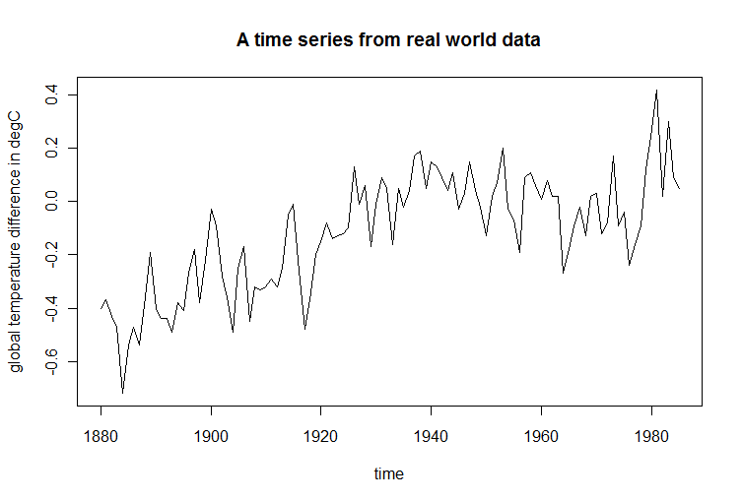
Figure A1: Illustration of time series from real world data. This graph shows average global temperature differences in surface air temperatures compared to an arbitrary zero point, over the period 1880-1985. Adapted from Hyndman (2012, taken from Hansen and Lebedeff, 1987, pp. 13345-13372).
The graph in Figure A2 below was generated from a time-dependent non-linear equation that included a random fluctuation. (Appendix B gives the R-code and equations associated with this and other diagrams in the text.)
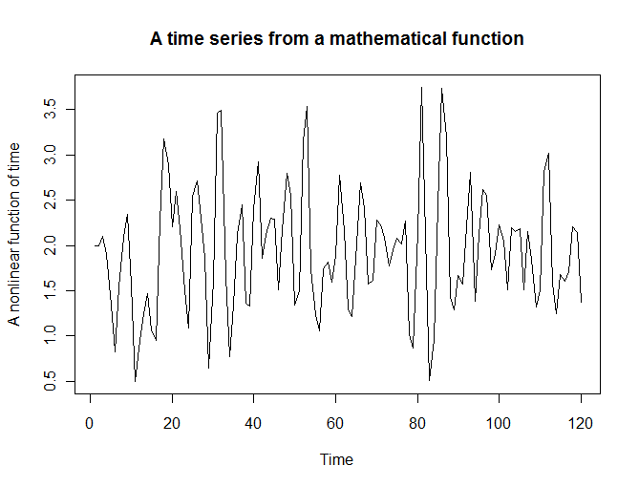

Figure A2: Illustration of time series from a mathematical function. A time-dependent equation with nonlinear terms can be structured to produce a time series similar to that which is produced in the real world.

When more than one variable is measured from a real situation or produced from a set of mathematical equations, the result is simply called “multiple time series” (see the diagram in Figure A3 below showing two measures from the same psychotherapy session). In the case of multiple time series we often want to know whether two or more variables are dependent upon each other, that is, are the values of one variable some function of the values of another variable, either at the same time or at previous times, or both?

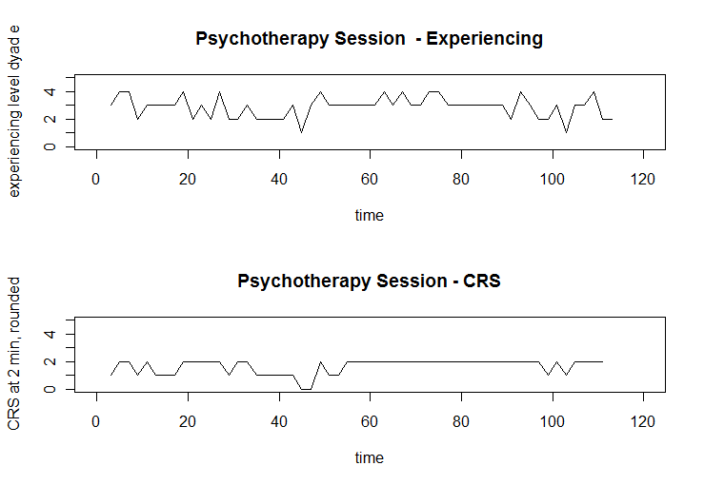
Figure A3: Illustration of multiple time series. The graphs above depict two measures taken from psychotherapy sessions, that are interdependent.

Likewise, we can attempt to model a real situation involving multiple time series by constructing equations that postulate how two measures might relate to each other. The following multiple time series in Figure A4 are generated by making up two arbitrary equations that are interdependent − for example, a client measure may depend a bit on how the therapist has been acting, and the therapist may respond to what he or she sees recently in the client measure.
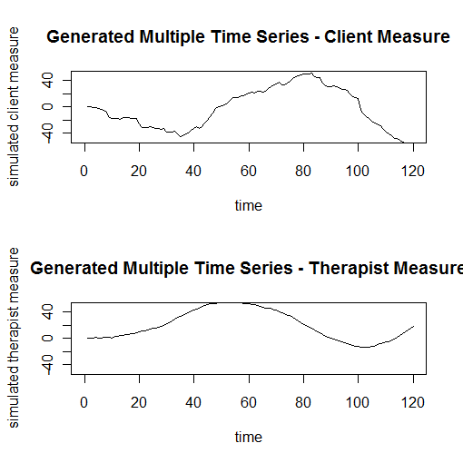
Figure A4: Illustration of multiple time series from interdependent equations. In this case arbitrary equations were structured that hypothesized a connection between client and therapist behaviours. The graphs show the therapist working harder when the client measure drops.

For both measures, there is a random component, but for this case the random component for the client has been assumed to be twice as large, on average, as the random fluctuations of the therapist, and more negative, as if this particular client were prone to intrusive depressive thoughts. (The R-code and the equations assumed for this simulation are included in Appendix B.)
But what is the purpose of looking at time series data? It is precisely because watching a system's behaviour evolve over time reveals all the “hallmarks of dynamical systems, including attractors, phase transitions, hysteresis, critical fluctuations, and the emergence of macroscopic order from lower-level interactions” (Vallacher and Nowak, 1994b, p. 9-10). In other words, it could tell us a great deal more about what we are looking at than merely taking “snapshots” of the same system at one or two points in time. Imagine the difference between looking at an old scratchy black-and-white photograph of one of our ancestors, and viewing a high-definition colour digital video of any individual carrying out an activity on camera today. In both cases we might say that we learned what the individual looks like, but we would be more inclined to say in the latter case that we gained some understanding of how the individual behaves.
What are Dynamical Systems?
In the time series literature, there is considerable reference to “dynamic” or “dynamical” systems (e.g. Vallacher and Nowak, 1994). In such works time series are associated with dynamical systems, which are described simply as phenomena that change and evolve over time (Nowak and Lewenstein, 1994, p. 18). In turn, system is just a very general word that defines any physical situation of concern. Gregson (1983) describes a system as “a collection of objects or events united by some form of interaction or interdependence” (p. 319). For example, a client and therapist in session can be referred to as a system. The actions of the client and therapist change as time passes. That makes the client and therapist both part of a dynamical system. In purely physical dynamical systems we say that things change because of forces acting on or within the system. In social dynamical systems, the actions of human beings change for various reasons, including changes in environmental stimuli or in their own and each other people's behaviours.
Nowak and Lewenstein (1994) claim that looking at time series data from dynamical systems is a departure from traditional empirical psychology, in which “time evolution is largely absent” (p. 19). But is this a false contrast? Is there anything remarkably different between a dynamical system like a client and therapist, and the traditional psychological study sample population who are studied before and after a particular intervention? If change is the measure of whether a system is dynamic, then the study population in a repeated measures study is dynamic, since not only might there be change as a result of intervention, but that change is indeed the focus of what we want to assess when applying statistics to the study results. We ask in such situations whether the intervention being studied is associated with a significant change in the study sample population or whether any change we might have observed is well within the chance sample and measurement variations that we would have seen if there had not been any effect of the intervention.
If client-therapist interactions and interventions on study sample populations are both dynamical systems, what is the big deal that makes them so different for researchers? My contention is that the difference lies in the distance of our viewpoint from the system we study. In client-therapist interactions we are up close and watching minute-by-minute interactions. In interventions that might affect study sample populations after a period of exposure, we stand back considerably farther, thinking of time only in terms of before and after, rather than as a ticking clock. In those studies we are also interested in understanding the overall average effects of some intervention over the entire study sample. We are not examining the detailed dynamics, the “hows and the whys” of an interaction unfolding minute-by-minute between two specific individuals.
In the kind of dynamical system we are considering in this paper, i.e. a client and a therapist in session, two actors affect each other back and forth repeatedly over the timespan of a therapy session. We are interested in both why each actor did what he or she did, and how each actor modified his or her own behavior based on their own previous actions and those of the other. In studying systems so closely that we can observe the detailed back-and-forth dynamic between two individuals, we can address questions like “what exactly is going on between those two?” as well as “is what they are doing with each other getting them where they want to go?”
Psychology has in fact always studied systems that are dynamic, and it is perhaps a false accusation that it has ignored time evolution. If we consider instead the distinction between looking at a phenomenon at a distance (either in space or time) versus up close, we can see that different branches of psychology just take different viewpoints on the dynamical systems they study. Personality psychologists may sometimes treat people as if they do not vary much, if at all, over time. Developmental psychologists look specifically at the time evolution of young human beings, but perhaps in terms of months and years, rather than in terms of seconds and minutes. An evolutionary psychologist may think in change over millenia. A specialist in vision may measure changes in microseconds. Psychologists who study interventions may focus on a particular point in time and compare before and after.
Clinical psychologists and psychotherapists, however, are forced to vary their viewpoint. They are necessarily concerned with before and after, since their goal is to make a difference in a client's life by the time they finish therapy. But they are also forced to consider minute-to-minute interactions with their clients, if only because they play a part in the system they are studying. They must answer the questions “what will my client do if I do this?” and “what should I do when my client does that?” If I wish to know what to do next, part of my focus has to be on the detailed dynamics of the system I am working with, as they unfold over time. It therefore makes a great deal of sense that researchers who are interested in helping therapists have better sessions with their clients should look very closely at client-therapist interactions. In doing so their observations will represent a time series. Studying system dynamics closely requires us to ask new kinds of questions, and as a result we may get new kinds of information about the systems we are dealing with. In later sections we discuss how mathematical models can be helpful in simulating the kinds of back-and-forth interactions that occur in psychotherapy. Simply put, we can make sets of equations that vary in time, and the numbers they can generate are also time series. If the equations we structure can produce numbers at all similar to those that were observed in therapy sessions, then those equations can be considered to model the sessions.
Before moving on, I think it is important to demystify several other concepts that are found in texts involving time series analysis. For example, some authors place another restriction on the use of the word dynamical when describing systems. Schroeck (1994) suggests that if we can determine the dynamics of a system (i.e. successfully understand how and why it evolves over time) it is conventional to call it a dynamical system. And if we cannot, it may be called chaotic. He adds, though, that systems that are confusing and not obvious to us are not necessarily chaotic, since a change in our viewpoint may help to establish a pattern or dynamic (p. 77). So if it changes it is dynamic, except when we can't understand it, in which case it is chaotic, unless we could have understood it if we tried harder, in which it is dynamic again.
Perhaps there is another way of looking at this that will make the distinction between dynamical and chaotic less important. First consider a client-therapist pair in which the change in one is related to the change in the other. In mathematical terms, there is something to model. In Schroeck's terms this is a dynamical system. Now consider a client-therapist pair in which there is no relationship between what the therapist does and what the client does (and vice-versa) In Schroeck's terms this might be called chaotic rather than dynamic. Mathematically, there is no interaction to model. In practice, and as it is shown elsewhere in this paper, the difference between dynamic and chaotic need not be a major concern, and when chaotic systems are considered, they can be more tightly defined mathematically. The analysis of the time series data produced by both client and therapist will reveal whether there is interaction (i.e. whether there will be some correlation between the actions of the two) or whether there is not. The equations used to model the interaction will either contain terms reflective of that interaction, or the equations will show independence from each other (i.e. the interaction terms have a coefficient of zero).
All that said, what is the value of looking closely at dynamical systems like the client and a therapist in session? Studying how and why a dynamical human system behaves, in detail, can yield considerable understanding of ourselves in the process. For example, Gottman et al. (2005) describe how some people are put off by a negative response from their spouse, and subsequently withhold positive responses they might normally have provided in the relationship. This suppression behaviour is common for couples whose marriage is in distress, but is not common among those whose marriage is rated as nondistressed (p. 15). This is the kind of system dynamics that can be investigated using observations over time (which produce a time series), and that can be modeled using coupled sets of mathematical equations, as will be discussed below in several other sections.
Should We Use Statistics on Time Series Data, or Statistical Dynamics?
Statistical procedures in the sense usually used in psychology help us to organize, summarize, and interpret the data we generate, in such a way as to make it easier to understand the meaning of the numbers we produced and to determine what conclusions we can justifiably make based on our results (Gravetter and Wallnau, 2009, p. 3). The more specific question relevant to the work described herein is “should we use statistics on time series data?” If we create a measure of client affect, for example, and generate numbers throughout a therapy session at many points in time, we can indeed use conventional statistics to calculate additional measures like average levels, standard deviation, etc. Each of these numbers by design contains far less information than the original data, yet they provide us with simple quantities that we can compare to other circumstances. Was client A on average happier or less happy with therapist 1 or therapist 2? In a good session, was there a greater variation in the client's affect than in a bad session?
The graphics in Figure A5 on the following page illustrate the extraction of conventional statistics from experimental time series data. The first graph indicates the values of the mean and standard deviation (quantified in the title), and shows the mean as a line through the data. The histogram illustrates the frequency distribution of the measures, and a probability density curve is superimposed. (The R code for these graphs is given in Appendix B.)

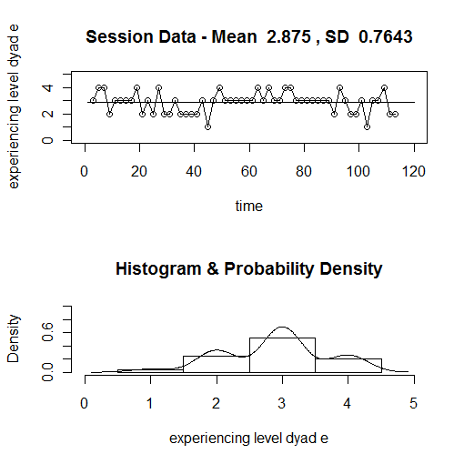
Figure A5. Illustration of extraction of conventional statistics from experimental time series data. The first graph indicates the values of the mean and standard deviation (quantified in the title), and shows the mean as a line through the data. The histogram illustrates the frequency distribution of the measures, and a probability density curve is superimposed.

Statistical procedures that are commonly used in psychological research are subject to the Central Limit Theorem, which requires that the procedures be performed on “a series of independent events” (Mandell and Selz, 1994, p. 58). But this theorem fails in dynamical systems wherein successive results in a time series are related. To apply traditional statistics, the data requires various operations to eliminate these relations from consideration. In the process of doing so, we sometimes eliminate most or all of the information of interest. In analyzing dynamical, nonlinear systems, traditional statistics have limited applications, and must be applied carefully in order to understand what it means to use those procedures in those circumstances.
Statistical dynamics is the name of a new discipline that deals with finding invariant behaviours within complex nonlinear dynamical systems. For example, if a system is highly sensitive to initial conditions, and its specific behaviour may change drastically depending on the stimuli received by the system, how can I learn about that system? I can neither predict its behaviour nor understand its dynamics because it never seems to do the same thing twice. But I can search for more subtle measures which are more constant over time. These “invariants of the motion” or “categories of equivalence” are measures of similarities between systems that produce widely different outputs, or between different results from one system that has widely different outputs from small changes in input (Mandell and Selz, 1994, p. 56).
Statistical dynamics is a set of mathematical techniques for nonlinear dynamical systems which help to identify similarities where they are not obvious from widely varying data. Mandell and Selz (1994) describe these as “the persistent, statistical, dynamic properties of the system that withstand its time-dependent, unpredictable details” (p. 57), and it is these deep characteristics of a dynamical system upon which hypotheses and experiments are built. For example, researchers would like to be able to categorize a psychotherapy session as a “good session” and distinguish it from a “bad session”, and to do so by looking at time series data from the session. Two sessions, even with the same participants, may yield widely different time series data. We need some way of determining whether both sessions were nonetheless successful, or whether they differ a great deal in their degree of success. Statistical dynamics offers hope of determining something relatively stable or constant about a system, even though its detailed performance is highly variable. We could imagine, for example, being able to determine that psychotherapy sessions that tend to reach satisfactory, stable endings involving positive affect and insight could be considered “good sessions”, even though the starting points and the routes taken in each session may be very different.
In summary, traditional statistical procedures need to be administered carefully in dynamic nonlinear systems because of the assumptions that restrict their applicability. Statistical dynamic procedures, however, are designed for use with nonlinear dynamical systems and to determine when there are fundamental similarities between results that on the surface may appear remarkably different.
Should We Use Mathematical Modeling?
In mathematical modeling, the operations are quite different from statistical analysis, at least in their purpose. In mathematical modeling, we seek to create in mathematical equations another “system” that produces numbers. We want the numbers that the mathematical system produces to resemble closely, in some critical way, the numbers that we produced from our psychotherapy session. We want to speculate, as a result of producing the mathematical model, whether something about our actual psychotherapy session produces numbers in almost exactly the same way as our model does.
According to Gottman et al. (2005), the goal in creating a mathematical model out of equations is to represent the dynamics of the system that you are studying, that is “how it moves and changes over time.” As such, they note that “the model itself is a theory the investigator develops about the phenomenon under study” (p. 67). It has two primary values. First it provides a way of formalizing our thinking about how an actual therapy session works, and a way of assessing those hypotheses against actual data. In so doing, we create an explicit language for discussing our system. Second, it allows us to simulate the actions of client and therapist under different circumstances than our original data was gathered. This allows us to predict how the actual client and therapist might interact (based on our hypotheses) and to test those results in further observations and experiments (Gottman el al., 2005, p. 128).
Mathematical modeling has been used successfully in the natural sciences to create systems using mathematical entities or notations, that produce results similar to those observed in physical systems (Brockwell & Davis, 2002, p. 6). We are used to talking about these equations as expressions of theories. For example, Newton's equation of classical mechanics (force equals mass times acceleration, or F = ma ) or Einstein's equation in relativity (energy equals mass times the square of the speed of light, or E = mc² ) are used as simulations of real life. These theories are models. The logic of mathematical systems allows these equations to produce numbers for us. If the equations can (with proper setup of initial conditions, etc.) produce numbers similar to what we can measure in an arranged experimental situation (or in natural physical systems, like the motion of the planets), then that equation can be said to model the real physical situation well. It does not reproduce the physical situation, which is far more complex than the model, but it does produce some information that strongly resembles some specific measurable parameters of the real physical situation. When we try to reproduce physical measurement data by creating data by means of equations, we are often attempting to create a model of the physical situation, that is, a simple system (in this case a mathematical equation) that not only duplicates the physical data, but helps us to explain in some way how the real physical system produces its data.
The question of producing a model that gives us insight into the way a psychological system produces its data is not as common in psychology as questions like “are these two variables strongly related?”. We are used to looking for both correlational and causal relationships between variables, but we ask less “how does this system really work?” Looking at psychological systems (for example, a client and therapist in session) as they evolve in time opens us a little bit more to the question not only of “how” our system changes in time, but that of “why” our system evolves in the way it does. Gregson (1983) states this as follows: “A time series analysis that is not purely exploratory is undertaken because it leads, with some high probability, back into a view of a psychological process or a phenomenon as a system” (p. 318).
For example, if we create a mathematical model of a psychotherapy session in which each successive number for the client is dependent on the last three successive numbers for the therapist, and vice versa, we will be modeling two highly interactive variables. If the numbers this model creates are very close to the numbers created by the real psychotherapy session, we may ask ourselves whether that means the two participants are adjusting their responses depending on the recent history of responses of the other person. The purpose of the mathematical model is to help us speculate on what is actually happening within the real situation.
It is important to note again that it is not the role of the mathematical model to try to imitate every possible aspect of the live situation. We all expect that even trying to do that would be so complicated that it would be discouraging. But we do expect to be able to model some aspect of the live situation. Just as we don't expect to be able to measure everything about the live situation in our analysis, we don't expect to model everything about it either. When it comes time to speculate about how the live situation really works, however, we need to be extremely careful to remember that we are speculating on a very specific aspect of it only. If, for example, I create a mathematical model involving feedback that closely reproduces the data from the live psychotherapy session, I may speculate that feedback could be involved in the live situation in some way, but it would be going too far to conclude that the live situation is “all about feedback”.
Sometimes we may create equations without thinking of them as models; we may only be concerned with finding a way of reproducing the data. In these cases we are fitting equations to the data, but we may not be concerned about what those equations mean about the system we are looking at. Whether an equation is a good model of the physical system we are studying will depend on more than goodness of fit. Several different kinds of equations may produce close approximations of the data, but that alone does not guarantee that the equation really models the way in which the physical system produces the data.
Psychologists are used to generating data about two variables in a social system, plotting them in a scatter plot, determining a line that best fits the data with linear regression analysis, and determining the strength of that correlation. They know that if the correlation is very close to +1 or -1, we consider the relationship linear. In this case, we produce an equation for a line, in the format y = bx + c and determine the exact values of constants b and c from the regression analysis. If we consider this equation as a model for our system, we are saying that we think the system produces its data in some physically linear way. (The next section will look at linearity in more depth.)
Because there is a great deal of experience with mathematical models reported in the mathematical, natural science and social science literature, we can confidently say that a great deal is already known about what kinds of physical actions can be simulated by various kinds of mathematical equations. There are a number of psychological researchers who have used mathematical modeling to increase their understanding of how social systems operate (e.g. Gottman et al., 2005). The work of Gottman et al. is encouraging because they modeled interactions between spouses. They were responding to a situation in which marital therapists were initiating complex interventions, but the overall results showed that only 35% of couples attained clinically significant gains. They began mathematically modeling marriage relationships so that they could investigate how to change from a bad spousal interaction within an experimental session to a better interaction, with simple interventions that were not designed to do anything but change the immediate style of interaction. The insight of the mathematical models allowed them to “change change marital interaction quite dramatically for a brief time with very simple interventions” (p. xiii). They also insist that even trying to create a mathematical model afforded them a simple and powerful language with which to talk about the marital interactions. They learned that building the mathematical models helped them to sit back and reflect upon marital interactions, by trying to assess what the models themselves meant (pp. xvi-xvii). If mathematical modeling has the potential for helping therapists and researchers sit back and reflect upon client-therapist interactions, there is no question that we could benefit from using mathematical modeling as part of the analytical process. Further aspects of the modeling process are discussed in other sections below.
What Is Linearity and Nonlinearity?
One question that seems to preoccupy researchers is whether the phenomenon they are studying operates as a linear, or a nonlinear system. Understanding the difference is helpful in reading the time series literature. In the most general sense, systems that are linear exhibit “proportional stimulus-response relations” (Mandell and Selz, 1994, p. 55). We are used to thinking that data in a linear system (plus measurement error) can be approximated with a line on a graph, similar to the diagram shown in Figure A6 on the following page. (The R-code for this diagram can be found in Appendix B.)

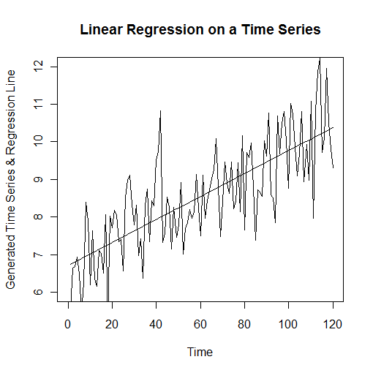
Figure A6: An illustration of the use of linear regression to create a straight-line approximation of time series data.

Simply put, a line on a graph is indeed a “proportional response relation”. If y and x are in a linear relation, if x increases by an amount, y also increases or decreases by a certain proportion of that amount. If there were a positive linear relationship between the degree of attention provided by a therapist and the amount of smiling by a client, the more attention received, the more the client would smile.
But human systems do not tend to operate linearly; responses are not always proportional. In fact, in social science experiments “linear relations are very rare” (Schroeck, 1994, p. 74). In a nonlinear relation, a therapist may increase the quality of his or her attention and there might be no apparent effect on the client. Or the therapist might show an almost imperceptible increase in interest in a client's story, and suddenly the client may switch from smiles to tears. Schroeck (1994) notes that when feedback plays a major role, a psychological situation is never linear (p. 76).
In nonlinear systems there can be “discontinuitous jumps” or “bifurcations” wherein the system changes suddenly, sometimes from “surprisingly small” changes in a parameter or in initial conditions (Mandell and Selz, 1994, p. 55). For example, weather is hard to predict because a tiny change in the initial conditions fed into a computer model (even a small difference in rounding methods for numbers) can yield an entirely different weather prediction by the model (p. 56). Mandell and Selz (1994) use the example of human opinions to illustrate non-linearity:
Our opinions generally do not change smoothly and in proportion to our knowledge of their objects. Instead, they may mature in leaps and pauses, may reverse themselves any number of times with increasing or decreasing variability in response to increased receipt of information. (p. 56)
The graphs in Figure A7 on the following page show two time series, both generated from the same nonlinear equation, but with different initial conditions. For the first graph, the parameter started (arbitrarily) at the beginning of the time series with a value of +1.0. For the second graph, the same equation was given an arbitrary starting value of -3.0, and further values were calculated from there. Not only do the resulting plots have lots of abrupt changes (typical of some nonlinear functions), but they have distinctly different shapes and values.

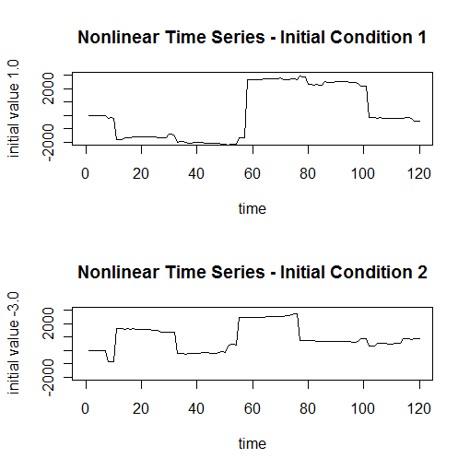
Figure A7: Illustration of the varying performance of a nonlinear equation under different initial conditions. Depending on how the sequence started, the graphs may look quite different. Both graphs also exhibit rather abrupt changes in values for no obvious reason.

In the real world of human beings, we would be hard-pressed to find anything we could measure that is truly linear. We may attempt to model a live situation with linear mathematics, but it is only the model that is linear, not the situation we are examining, Much work on data in both psychology as well as in the natural sciences involves making mathematical models that are simpler than the real world, but which themselves can produce data that in some way resembles the real-world data that was measured. Gottman et al. (2005) conclude that “linear models are seldom justified” and that it is becoming clear that most situations are complex enough to require nonlinear modeling. They suggest that by employing nonlinear terms in the equations “some very complex processes can be represented by very few parameters” (p. 37).
The main reason for making this distinction between linear and nonlinear is because different mathematics apply. There is no other magic than that. The real situation we are examining is what it is, whatever mathematics we use to try to understand it. Finding a linear relationship (if it really exists) is no better or worse than finding a nonlinear relationship. It may be much easier to model mathematically, but there is nothing inherently better about it. Schroeck (1994) emphasizes that once you divide relationships between variables between linear and nonlinear, it is useful to note that there are “degrees of nonlinearity” (p. 76). He divides relationships according to the mathematical methods that are applicable: (1) situations in which linear methods apply, (2) situations in which “coherent state” methods apply, and (3) situations requiring more general nonlinear methods. Coherent state methods are applicable for systems that exhibit “fundamental patterns” or “coherent states” which are determined from auto-correlations and cross-correlations (p. 77). (These are discussed further in the next section.)
When mathematical expertise was more limited, a great deal of effort went into linear models because they could be handled easily within the limitations of calculating technology available at the time. There is also a scientific strategy which seeks to find the simplest model that will help to explain what we are interested in, and this too led people to seek linear models when possible. Greater experience in nonlinear mathematics and major advances in computing technology have allowed people to look more than before at nonlinear mathematical models. In fact, some nonlinear models may be simpler in many ways than linear models. (This will be demonstrated in a later section.)
Mathematically, there are a number of ways of expressing linearity and recognizing nonlinearity (Schroeck, 1994, p. 76). A simple linear relationship between two variables is expressed mathematically as y = ax + b (where a and b are constants). Linear relationships are subject to linear analysis, including matrix theory and linear differential equation theory. An example of a linear differential equation is dy/dt = 2y. A nonlinear differential equation could look like dy/dt = 2sin(y). If y is small, sin(y) can be approximated by y, yielding a linear approximation (Gottman et al., 2005, p. 37).
Once the equation or set of equations departs from the simple linear format, the relationship is nonlinear. According to Schroeck (1994) even a quadratic equation (one involving x²) is nonlinear: y = ax² + bx + c , where a, b, and c are constants (p. 77). More general polynomials can be written in the form y = a + bx + cx2 + dx3 + ….. + KxP (Gottman et al., 2005, p. 47). Systems with quadratic behaviour may exhibit patterns that can be recognized with “coherent state” analysis, and are therefore given special treatment (Schroeck, 1994, p. 77). Some nonlinear equations can be translated into linear forms and thereby become suitable for analysis by linear methods (Cowpertwait, 2009, p. 92). In the quadratic example above, and in higher order polynomials, the powered “predictor” variables can be replaced with other single variables (not to a power) that make the equation look linear. From this point of view “the term 'linear' is a reference to the summation of model parameters, each multiplied by a single predictor variable” (p. 92). Other nonlinear equations such as those with exponents can also be operated on to become linear equations, for example: $x_{t}=e^{\left(α_{0}+α_{1}t+z_{t}\right)}$ can be operated on by the natural logarithm function to make a linear relation as follows: $y_{t}=logx_{t}=α_{0}+α_{1}t+z_{t}$. Once linear analysis has been done, the process is reversed by taking the exponent and applying certain correcting factors,
There are many other forms of functions appearing in nonlinear equations, involving higher polynomials (x³, x⁴ etc.), exponentials (e.g. ex), logarithms (e.g. log(x), ln(x)), trigonometric functions (e.g. sin(x), cos(x), tan(x)), and others. These require more general nonlinear theory (Schroeck, 1994, p. 77).
What Behaviours Are Common in Nonlinear Dynamical Systems?
Simply defined, a nonlinear dynamical system is a “more-or-less self-contained set of elements that interact over time in complex, often nonlinear ways” (Vallacher and Nowak, 1994b, p. 2). When researchers have looked at nonlinear dynamical systems up close, they found that these systems have the capacity “to show amazingly complex behaviour from simple rules” (Nowak and Lewenstein, 1994, p. 19). Conversely, when modeling these systems, it can be shown that slight changes in the rules can in turn result in dramatic behavioural changes. These behaviours are a result of the coupling or feedback among variables that help to describe a dynamical system. Nowak, Vallacher and Lewenstein (1994) emphasize, as noted previously, that “the time evolution of each variable is determined by values of other variables in the system” and that “each variable is both a cause and an effect at the same time” (p. 282).
The challenge in dealing with nonlinear dynamic systems is that the complex interconnection of variables makes behaviour prediction difficult. Vallacher and Nowak (1994b) sum this up well:
Because each unique pattern of interactive feedback among system elements may be associated with a qualitatively different state of the system, and because the slightest change in the value of a single system element can make a profound difference in what state is observed, it is often impossible to specify exactly what the system will be doing at some distant point in the future. (p. 9)
At the same time, nonlinear dynamical systems often have self-organizing behaviours that lead to very recognizable characteristics. There are many potential regularities and patterns that nonlinear dynamical systems can exhibit, that are known by names such as attractors, phase transition, mixing, bifurcations, hysteresis, butterfly effect, inertia, critical instability, intrinsic dynamics, fractals, chaos and more (Nowak and Lewenstein, 1994, p. 17; Vallacher and Nowak, 1994b, p. 14). Most of these are easily characterized by reference to a graphical technique known as phase space, wherein several key variables are plotted against each other and the resulting points describe the state of the system. As the system evolves in time, its point in the phase space changes position, giving rise to a trajectory in phase space (p. 21). (The reader is referred to Nowak and Lowenstein (1994, pp. 20ff.) for a more complete discussion of phase space.) For the purpose of introducing nonlinear dynamical behavioural in this handbook, however, I have deliberately relied below on word descriptions that may be more likely to evoke familiar concepts and images in those readers who are unfamiliar with the graphical techniques. The phase space descriptions can be made mathematically very accurate, but for some they lack the intuitive grasp that word descriptions may provide at the early stages of understanding.
The word attractor describes a region in phase space that the system evolves toward over time (Nowak and Lewenstein, 1994, p. 25). If we were to observe such a system directly (rather than plot its trajectory in phase space), it would appear to settle into or nearly into one specific mode, given enough time. If a system has only one attractor, it evolves over time “to a more-or-less steady state”, and “useful knowledge of the system can be garnered from observing it at a single point in time” (Vallacher and Nowak, 1994b, p. 10). The pendulum of a clock, for example, will slowly settle into a vertical position over time, if the clock is not wound. Any dissipative system, that is, a system that is winding down like the clock, will end up approaching its attractor state, no matter what other state it started out in (Nowak and Lewenstein, 1994, p. 25).
Other systems have more than one attractor, and can exhibit “oscillation among two or more different states in a rhythmic fashion over time” (Vallacher and Nowak, 1994b, p. 10). Such attractors are called limit cycle or periodic attractors and show as a closed trajectory in phase space, with the amplitude of the oscillations of the system being dependent on initial conditions (Nowak and Lewenstein, 1994, p. 27-29). For example, predator and prey populations may oscillate in their respective numbers back and forth every year, as each adjusts to either a lack or abundance of the other. In social interactions (including therapy sessions) the normal “give and take” could also be seen as a periodic behaviour, as might the behaviour of two individuals developing and maintaining a long-term intimate relationship (Vallacher and Nowak, 1994b, p. 12). Systems can also exhibit multi-periodic or quasi-periodic behaviour. In the former, the system oscillates in a way that incorporates two or more different but related or commensurate frequencies at once (much like a guitar string may vibrate with a fundamental frequency as well as harmonics). The latter involves oscillations with two or more unrelated frequencies, which lead to the system oscillating back and forth but never quite returning to exactly the same state as before (Nowak and Lewenstein, 1994, p. 29; Vallacher and Nowak, 1994b, p. 10). An example might be the interactions between a student and a teacher during the school year as the student gains skills and confidence in the process. In phase space, multi-periodic and quasi-periodic systems may create “very irregular and quite complex” (and sometimes quite beautiful) shapes (Nowak and Lewenstein, 1994, p. 29).
One additional type of attractor is called a strange attractor, which describes a system that has a trajectory that is not easily categorized. It is close to being a chaotic system, in which there is no discernible pattern to the system's trajectory through states. In both of these types, systems “exhibit the peculiar property of being enormously sensitive to initial conditions” (Nowak and Lewenstein, 1994, p. 31). Starting such a system out in each of two similar but not identical initial states, at a given time later, the system would be in two completely different states (and areas of phase space) in the two trials. It is easy to imagine, for example, that a particular client and therapist in a session together might conduct their session in two very different ways, depending on a minor difference in how they could have started out. This is known as the butterfly effect, and is known to be responsible, for example, for the difficulties involved in making weather forecasts with any degree of accuracy (Nowak and Lewenstein, 1994, p. 31).
In hysteresis, a system may naturally take one trajectory to get from the first state to a second state, and an entirely different trajectory to get back. Most people are familiar with the fact that it might take only an instant to become injured or ill, but take many months and a lot of treatment in order to heal. Or that it may take months to build trust with a teacher or therapist, and only a few minutes of negative or exploitative interaction to destroy that trust.
Of particular interest to the study of psychotherapy sessions is that some systems can exhibit sudden changes in state (or phase transitions) when certain conditions change (Vallacher and Nowak, 1994b, p. 11). Just as a horse can be spurred from a trot to a gallop, so human interactions may sometimes shift abruptly from friendly co-operation to antagonism, for example, if one discovers that the other is not being truthful. Sometimes the same individuals can find ways to repair the damage and re-establish more stable steady states or back-and-forth dynamics similar to before (p. 12).
It is also important to note that looking at the time-varying behaviour of a nonlinear dynamical system is an effective way of studying the increase in order that is often characteristic of living systems in general, and human systems in particular. In a review of the dynamic behaviour of open systems, Small (1975) concludes that “it is possible to attain higher and higher degrees of order within a system with the appropriate arrangements of input, outputs and internal processes” (Small, 1975, p. 27).
In summary, there are many regularities and patterns that can be discerned that signal to the researcher that he or she is dealing with some form of complex nonlinear dynamical system. Once we know that, it becomes important to observe the system as it “unfolds over time” to gain more knowledge of its characteristics, states and trajectories. Studying these can yield important knowledge about the rules of interactions among the system's elements (Vallacher and Nowak, 1994b, p. 11). And once these rules of interaction are better understood, it is possible to simulate the interactions among the variables using coupled sets of mathematical equations as models for the dynamical system.
How Do I Choose Order Parameters for a Dynamical System?
One of the biggest challenges in modeling a dynamical system is choosing a small number of ways of characterizing features of the system that are relevant to your interests. In the case of a psychotherapy session, there are millions of ways of describing the system, depending on the amount of detail that is important to you. To be practical, a very small number of macroscopic or globally representative measures need to be identified that are relevant. Many different choices for modeling a psychotherapy session could be chosen. Each of those models might yield a different insight into the dynamics of the session. The term order parameters is often used for these key global dynamic variables you choose to explore your system (Nowak and Lewenstein, 1994, p. 20).
Gottman et al. (2005) began their modeling of marital relations with the results of their research that related the balance of negativity and positivity in certain interactions between spouses, and the likelihood of those partners either getting divorced or staying together (p. 6-7). This in turn directed their first choices of order parameters for mathematically modeling marriage. Eastwood and Gaskovski (2010) began their work on time series analysis of psychotherapy sessions by measuring client affect and the client-therapist relationship. Other research had shown a positive correlation between the therapeutic alliance (the degree of consensus and collaboration between client and therapist) and therapy outcomes across many different forms of therapy. In addition, research linked the likelihood that clients would engage in the exploration of feelings regarding their own problem issues with the strength of the client-therapist alliance. These two examples illustrate how one starting point can be the gathering of specific data from actual human interactions. Which interactions are studied and which observations are made that provide data will depend on a number of factors including the interest of the researchers, the study population available, time and resources available, interests of funding agencies, results of previous research, and other factors.
As discussed in an earlier section, mathematical models are in fact expressions of theories. When modeling proceeds from observational data, it essentially creates a theory, expressed mathematically, that attempts to explain that data. Whether the equations and the theory accurately explain such observations is not always confirmed by a “best fit” of the model results with the data observed (Gottman et al., 2005, p. 68). In fact, several different mathematical models might produce numbers that both match well the real-life observations. To verify a mathematically expressed theory a great deal of effort is required to understand the meaning of the mathematical model, and how accurately the model may predict other real-life situations that have not yet been measured rigorously.
Modeling can also originate with a theory that has no basis yet in empirical observations. (The history of psychology is full of such theories, and many researchers are still busy trying to prove or disprove them.) We can, for example, make a guess that a client's willingness to explore inner feelings within a therapy session may increase or decrease in proportion to the amount of caring attention he or she receives from a therapist. We can model this assumption mathematically by forming coupled equations using as key variables some measure of delving into feelings, and some measure of providing attention. (This is in fact what some of the programmed examples have done in earlier sections.) This mathematical model can then be used to generate (predict) numbers for these variables. It is then up to the researchers to set up an observational situation (of real-life events or of an experiment) in which they can gather data that represent these particular variables in an actual therapy session. Again, a great deal of thought is required to determine whether any resulting matches between modeled data and actual observed data actually confirm the theory embodied in the equations.
In practice, modeling may proceed in both directions at once. Imagine a psychology researcher talking with a mathematician. The researcher attempts to convey to the mathematician what he or she knows (from data) and thinks he or she knows (from theory) about a psychological phenomenon of interest (in this case an actual therapy session). The mathematician responds with clarifying questions, and ultimately proposes that several coupled equations can be structured to embody these ideas and assumptions. The researcher responds with clarifying questions and ultimately decides how he or she can set up further observations and experiments that would help to inform adjustments to the model and confirm whether the model produces numbers that resemble what empirical observations actually produce. The process continues back and forth until both psychology researcher and mathematician have honed both the model and the observational situation together into an instrument that will advance their knowledge about what interests them about therapy sessions.
Whether or not the mathematical model remains useful after this process is not critical. If the model has contributed positively to the design of competent observations, experiments and subsequently conclusions from them, it will have served its purpose. If both researcher and mathematician were lucky enough that the model they created was confirmed rather than disproved, perhaps the model will have a longer life and serve some additional purpose, for example in educating future psychologists as to how or why certain human interactions take place.
Who or what should drive the choice of what observations to measure and what parameters the model should simulate? From the psychology researcher's point of view, it makes sense that the interests of the researcher in specific psychological phenomena should dictate what gets observed and modeled. From the mathematician's viewpoint, the question of what phenomena can be effectively modeled, and what kind of mathematical skills, programming resources and computing capacities are available, and what kind of equations the mathematician likes most may have more bearing on what parameters should be represented by the equations. There appears to be no simple rational formula for what should happen next in science. In fact, much of the orientation of empirical research and analysis in contemporary psychology is geared towards specific types of statistical analysis, and while a great deal of knowledge has been generated by this process, its focus has also been inherently limited by the restriction to this particular kind of mathematics. As mentioned previously, looking at time series data in psychology is a relatively new phenomenon and it is partly made possible by advances in other fields where time series analysis became necessary.
The only simple answer to the question of which order parameters to choose is to start somewhere, and even anywhere, and let the interactive process between observation and modeling guide modifications until useful parameters are discovered and verified. Making this trial-and-error process efficient is the biggest challenge in research, but embracing an iterative process as described above can be a useful way of doing so.
What Do I Need to Know About Stochastic Processes?
Gottman et al. (2005) trace the introduction of stochastic models for human interactions to the mid-1970s. The term stochastic refers to processes that involve probabilities and uncertainties, where the outcomes may vary according to numerous factors including random changes (p. 15). Certainly human interactions are not predictable in detail, though we might have some idea how the general result will turn out. A single session between a therapist and a client can go in any of thousands of different directions, for example, but we may still be concerned at the end whether it was a “good” session or a “bad” session in terms of advancing the client's therapeutic goals. The question we must address is how, with that much potential variability, can we possibly deal mathematically, either directly or through models, with the measured results of a therapy session? Is there anything we can possibly grasp about it that will not change completely the next time we look at it?
The simplest version of stochastic uncertainty is the distinction between signal and noise. For example, a system may exhibit a varying signal in time that could be described by a sinusoidal function, e.g. Xt = a cos(t) + Nt , where t = 1,2,3, …... 200 and N is a set of random normal variables with a given mean and standard deviation (Brockwell & Davis, 2002, p. 3). Given the signal a cos(t) and noise Nt separately, we can clearly distinguish what is happening. Given the two combined, it is less clear what the real signal is, and what is only random noise. In terms of the challenge of analyzing data from actual psychotherapy sessions, it may not be as easy to understand which aspects of a client's behaviour, for example, are strictly due to the circumstances of the session and the interaction with the therapist, and which aspects are merely random fluctuations similar to what may happen to the client under any other circumstances. In this case, random fluctuations really means something like “minor variations in the data that are due to a myriad of other factors we are either not interested in or cannot keep track of or both, and that average to little if any effect”.
Further discussion of the random component is found in a later section dealing with structuring equations in a mathematical model. The reader is also referred to Brockwell and Davis (2000, pp. 18-35), Schroeck (1994, p. 84ff.) and Chapter 5 of Cowpertwait and Metcalfe (2009, p. 91ff) for more information on stochastic processes.
In addition to changes due to random factors, there is a kind of uncertainty that needs to be dealt with that has to do with the nature of nonlinear dynamical systems, as discussed in earlier sections. Some nonlinear dynamical systems may exhibit large changes in behaviour, including qualitative shifts in the type of behaviour, with small changes in initial conditions, external influences including random changes, and in the system's own rules of dynamics. When equations are used to mathematically model nonlinear dynamical systems, they too may exhibit similar shifts with even minor changes in the coefficients of existing terms in the equations, and with different inputs from random functions used in the equations. Even with one set of coefficients and the same initial conditions, the equation set will produce a family of output time series, rather than a single time series, when the equations are recalculated with a different invocation of the random inputs. In other words, just pressing the button and running the program again without any changes will yield visibly different results in the output time series.
Therefore we have an actual therapy situation that is capable of delivering quite different outputs from the same people at different times, modeled by a set of equations that will give a different set of outputs each time they are run on the computer. It becomes very clear that matching a single output from the modeling equations to a single output from the client-therapist dyad may not prove much. This is one of the reasons why it is important to understand and measure the deep characteristics of each system. The one set of equations that delivers different outputs because of the inclusion of a random component may nonetheless exhibit a clearly definable deep characteristic that is reasonably invariant over the different possible outputs. The same may be true for the actual therapy data. Comparing the two sets of deep characteristics may make more sense than worrying about securing a detailed fit from one specific time series to the other.
What is Auto-Correlation?
Auto-correlation is a term describing a relationship between a single variable at time t, for example xt , and the same variable at a previous time, for example xt-τ. If the variable depends on its own magnitude at one or more previous points in time, it is auto-correlated (Nowak and Lewenstein, 1994, p. 43). For example, if my mood is slow to change, even in the face of a strong stimulus, it may be auto-correlated; whether I am still grumpy after someone smiles at me may depend not only on the strength of that smile, but on whether I was grumpy before it happened.
Cross-correlation involves two or more variables and previous times. For example, my mood could be dependent not only on what my therapist says right now, but on how he has treated me up until now. In mathematical expressions, my mood now ( xt ) is dependent on his treatment now ( yt ) and his treatment before ( yt-τ ). The equation might look like xt = F(yt, yt-τ) and means that x at the present time is a function of y at the present and y in the past.
Auto-correlation concerns researchers because they want to know whether their system has it or not, and whether for their purposes that makes it easy for them, or difficult. Whether it is good or bad for them will depend on the kind of statistical procedures they are planning to use; the system itself is neither good nor bad for having auto-correlation. If the data shows some degree of auto-correlation or cross-correlation, that just tells us something about the dynamic system we are examining.
Traditional statistical tests are based on an assumption that a series of observations are independent, that is, their values are not dependent on the values of the other measurements. To the extent that data are auto-correlated or cross-correlated, this assumption is violated and the analysis might end up with increased false differences (Type I errors) or increased failures to detect differences (Type II errors) as a result (Bloom, Fischer and Orme, 1999, p. 521). In order to use conventional statistical analysis with any confidence, the auto-correlated data must be transformed in a way that substantially removes the auto-correlation, using such methods as first differences transformation or moving average transformation. Bloom, Fischer and Orme (1999) caution, however, that “if you do transform the data, you will be losing many of the original characteristics of those data” (p. 526). They therefore describe auto-correlation as a “serious problem”.
In statistical dynamics, on the other hand, auto-correlation is an accepted part of the data landscape and is a measure to be explored and used rather than eliminated. In this approach, a useful auto-correlation function C(τ) can be calculated which measures the correlation between measurements of a variable at different time separations, averaged over all the values of time, as can a similar measure for cross-correlation (Nowak and Lewenstein, 1994, p. 43). This and other functions that represent deep characteristics of a dynamical system can then be used to help assess the “topological equivalence” of experimental observables and data produced by theoretical mathematical models (Selz and Mandell, p. 194), even though visual inspection of the data reveals gross differences.
For further discussion of auto-correlation the reader is also referred to Brockwell and Davis (2002, p. 18ff).
How Do I Structure Equations to Model My Data?
I cannot pretend to provide a good answer to this question. The simplest answer for the psychological researcher is to ally with a counterpart (student or faculty) in the field of mathematics and ask them. The most general answer is whatever works. Any equation that happens to produce data in a manner similar to the actual situation you are studying is fair game. Before exploring this further it might be helpful to describe what the equations might look like and how they might be calculated.
Earlier I talked about coupled equations. This means simply that the mathematical model we intend to create involves more than one equation, and that the value of some important variable stipulated in one equation at a particular time is affected by (i.e. is partly a function of) the value of the variable stipulated by the other equation, either at that time or earlier. This might look generally like:
Qa(t) = Qa0 + f(t) + f0[Qb(t)] + f1[Qb(t-1)] + … + fn[Qb(t-n)] + fr[v(t)] (1)
Qb(t) = Qb0 + g(t) + g0[Qa(t)] + g1[Qa(t-1)] + … + gn[Qa(t-n)] + gr[w(t)] (2)
In the Equation 1, the left hand side describes a variable Qa of interest for person “a”. This might for example be the affect of a therapy client. The value of Qa is built up by adding the values calculated from a number of separate expressions or terms in the equation. The first term Qa0 is just some constant representing a base value from which Qa is calculated. The second term f(t) means that the variable Qa at the time t is built up first by calculating a term that is some direct function of time (like sin(t) or cos(t) if Qa is likely to fluctuate between two limits over a period of time, or like e-t if Qa is likely to decline steeply to a minimum over a period of time). Gottman et al. (2005) describe this kind of term as representing uninfluenced behavior since it is not a function of the other person's behavior (p. 130). The next two terms of the equation for Qa at time t are functions f0[Qb(t)] and f1[Qb(t-1)], which bring in quantities that are related to the other variable Qb at times t and t-1, and represent influenced behaviour. If for example Qb is trying to represent the attentiveness of a therapist, these terms (and the n terms following as shown) add a value to Qa that is dependent on the therapist's attention at the same moment and at the previous moment. If Qa is likely to be affected by even earlier moments, additional termas are added as shown. Finally the last term indicates that the value of Qa is also adjusted by some random amount, shown here as a function fr of the value v generated by a random number generator with specified distribution and characteristics. The second equation is built similarly as the sum of a direct function of time, functions of the other person's value at the same and previous times, and a random component. One could also model more variables with additional equations for each variable, coupled as necessary to the other equations.
Some researchers choose to begin with differential equations in the following form:
dQa(t)/dt = f(t) + f0[Qb(t)] + f1[Qb(t-1)] + … + fn[Qb(t-n)] + fr[v(t)] (3)
dQb(t)/dt = g(t) + g0[Qa(t)] + g1[Qa(t-1)] + … + gn[Qa(t-n)] + gr[w(t)] (4)
This is done so that the equations literally define what changes each variable, since the derivative dQa/dt represents the rate of change over time of the variable Qa , at that particular moment. In this case the computer routine that calculates successive values first determines the rate of change (or slope on a graph of values versus time) at the last point in time, then projects a new value of the variable at the next time based on that rate of change. Whether the derivative form or the direct function form is chosen is a matter of mathematical convenience; the second set of equations actually represents the derivative of the first set, and is functionally equivalent. (For a simplified discussion of derivatives and the rules of differentiation, consult Gottman el al. (2005, pp. 53-55). Gottman et al. (2005) chose to use the derivative form because it makes more explicit “the precise mechanism of change” (p. 36). For a simplified discussion of the mathematics of change and the use of the derivative to represent slope of a function at a point in time, consult Chapter 4 of Gottman et al. (2005, pp. 41-64). Note that in the case of continuous time series, it is appropriate to use differential equations with dQ/dt, whereas with discrete time series, it is appropriate to use difference equations with ΔQ/Δt, or Q(t+1)-Q(t) for a specified time interval (Nowak and Lewenstein, 1994, p. 23).
But how is any term in such equations chosen? We return to the question of how a researcher can build an equation that models actual psychotherapy sessions. Assistance from others who have a feel for the performance of nonlinear functions can be helpful. Alternately, such an understanding can be built by using a computer routine to display the effects of any function graphically. Which terms you choose will depend on which graphic form (that is, the shape of the curve produced by the equation) you need to simulate the results of actual psychotherapy sessions.
Which terms you choose also depend on the theory you are incorporating into the model and the equations. For example, if you hypothesize that some of the client behaviour is driven by therapist behaviour, there must be a term that links the two. Perhaps the more attentive the therapist gets, the more likely the client is to become introspective and express their feelings about topics they are exploring. Or the converse, the less attentive the therapist is, the more the client closes off or feels negatively towards the therapist. If you hypothesize that a client learns how to use a therapy session to some extent independent of the therapist's actions, you might include a term that shows the client changing with time alone, perhaps starting at a normal level of affect, showing more emotion and negative affect while they are looking inward, and then coming back to normal affect by the end of the session. This could be modeled with the second half of a sinusoidal cycle, for example.
It is also possible with computer algorithms to build equations that change form as events unfold, since as discussed below, the values are calculated recursively by computer and conditions can be tested at any point in time before deciding how to continue calculating. For example, if a therapist is modeled to show a normal range of attention while the client is in a fairly normal range of affect, he or she might be modeled to check at every moment to determine whether the client is on the way up or on the way down in terms of affect. We could hypothesize that the therapist supplies redoubled attention when the client is on the way towards negative affect and deeper introspection. This can be modeled using an “if” statement in the computer routine that literally changes the equation (or a term within it) to another one if the client variable is decreasing rapidly. In this manner, equations that vary according to conditions can be structured, and you can imagine this modeling the different states or modes that either the therapist or the client can operate in.
Random changes that occur by chance in both therapist and client can also be simulated using variables than can be calculated by the computer (see next section). In Equations 1 to 4 above v(t) and w(t) represent random number generators, that is, a computer routine that effectively tosses dice and chooses an arbitrary value to add to the equation. These are generated in such a way that over time, the random values generated form a known distribution that you can specify, for example, with a given mean and standard deviation. You can use different distributions for client and for therapist, and weight their effects differently as well, for example, by hypothesizing that the therapist by profession is more controlled and less random in behaviour than the client.
Brockwell and Davis (2002) describe a process they call the classical decomposition model, which they use for parsing components from a time series of actual data. This breaks a variable down into a trend component mt (e.g. general rising or falling), a seasonal component st (periodic rising and falling) and a random noise component Yt, represented in the following equation (p. 23): Xt = mt + st +Yt . Manipulating the time series to extract these three components allows a researcher to assess the nature of the random noise component and by analysis determine what kind of random generator function would best simulate the kind of variation it represents, when trying to model the original data. If the random component represents what they call a stationary time series (one with limited variation of statistical properties with time), it can be simulated with one of a number of standard stationary processes (p. 14-15, 24). If there is no auto-correlation or dependence between the residual noise data points, estimating the mean and variance is sufficient to make a basic model of the noise component. If they are dependent, a more complex stationary time series model of noise must be sought (p. 35). The reader is referred to Brockwell and Davis (2002) for further mathematics dealing with the random component and with stationary processes.
How Are the Values in the Equations Turned Into Time Series?
A detailed example is given below to illustrate how coupled equations are structured and how their values can be calculated by a computer routine. The routine first assures that the equations have enough beginning values to calculate properly. For example, if the equations are dependent on each other's value up to two moments previously, we may have to supply the first three data points for one variable in order to calculate the other. Then the computer routine hops back and forth, for example, calculating first Qa then Qb successively for each point in time and retaining memory of the results so that the next moment can be calculated depending on previous moments. After a sufficient number of rounds, the computer will have completed calculating the values of a full time series for each of Qa and Qb .
The following lines in R programming demonstrate simply how this process unfolds:
(1) for(i in 2:100){
(2) y[i]=y[1]-b*sin(i/32)-c*sin(i/4)-d*(z[i-1])+e*v[i];
(3) if (y[i] < 0.0) m[i] <- y[i]^2 else m[i]=0;
(4) z[i]=z[1]+g*sin(i/32)+h*m[i]+p*w[i];
(5) };
Lines 1 and 5 above set up the recursive loop, allowing the computer to calculate successive values of y(i), the variable representing client behaviour, and z(i), the variable representing therapist behaviour, with time being i rather than t in this case. Line 2 calculates the client variable as the sum of several terms, including an initial value y[1], a couple of sinusoidal terms b*sin(i/32) and c*sin(i/4) which make the client behaviour do one big dip in value and return, from beginning to the end of the session, as well as several small dips within the session. Another term d*(z[i-1]) makes the client behaviour change in proportion to the level of the therapist's behaviour at the previous moment. The final term e*v[i] makes the client variable change according to some random value chosen by the computer as part of a distribution of random values. Any appropriate terms can be added or substituted in the client equation.
Likewise line 4 of the computer sequence above describes the behaviour of the therapist, in this case by a simple sinusoidal component g*sin(i/32) independent of the client, rising toward the middle of the session and resuming initial values by the end. There is also a random component p*w[i], though designed to be less than that of the client, and an additional term h*m[i] that is linked to the client in line 3 above it. Line 3 changes the equation depending on the circumstances. If the client's behaviour is positive (e.g. positive affect), there is no contribution from the client value (that is, m[i]=0 ). If the client's behaviour is negative, this line gives a value to the therapist's term h*m[i] by making the value of m[i] be the square of the client's variable, in order to make it proportional to the absolute value or magnitude of the client variable ( m[i] = y[i]2 ). This is like saying that the therapist in this model works harder when the client shows negative affect. Again, any appropriate terms can be added or substituted in the therapist equation, and any number of conditions (“if” statements like line 3) can be attached to any term of either the client's or the therapist's equation. Because the computer is doing the work of turning the equations into numbers and graphical representations, the complexity of the mathematics used and the variability of the equations according to detected conditions are not inhibiting factors in the research.

Appendix B
Use of R for Calculation and Display of Time Series Analysis

The following appendix is intended as a guide to future students/researchers in the use of programming in R to generate automated routines to evaluate time series and create and manipulate mathematical models or simulations of therapy dynamics.
General Comments About R
It looks like having a programming language like R is advantageous because it provides a great deal of latitude to create any kind of calculation or display that we might want. That said, the online help available through R is not very helpful for the lay person, and can be confusing even for someone with decades of programming experience in other languages. It is more likely comprehensible by the experienced R programmer, who in turn likely doesn't need it much. For those without daily familiarity with R, it is easy to forget how to use it from one session to the next. It therefore seems critical to keep easily accessible records of how you used it, and well-labeled files for programs that were run and/or experimented with and revised in each session.
I am attempting to extract here the minimum R command expertise necessary to begin calculating, displaying and analyzing time series for psychotherapy. A number of references dealing with R and time series are also available for the interested reader (Cowpertwait & Metcalfe, 2009; Cryer & Chan, 2008; Gentleman, 2009; Shumway & Stoffer, 2006; Zucchini & Nenadic, n.d.).
Creating Command Files (Programs) in R
R manifests on the screen as a “command prompt”, similar to what people were used to in MS-DOS, decades ago. It shows as a caret (>) at the left side of the screen, with a space between the caret and the cursor, which awaits your input. An R command is an instruction line sent to the “R” program to tell it what to do. These instruction lines follow strict formatting protocols, that are described (badly) in the R online help manuals. R commands can be typed in to the right of the caret (>), and the program will execute each command before prompting for the next.
Alternately, a series of R commands can be stored in a text file and run altogether as a batch of commands. R has a built-in editor that is accessible using the commands “File, New Script” (in the Windows version, top left of the page). You may type commands here and save them as a file. It may be preferable to give the R command files a suffix like “.R” so that they can be easily distinguished from other types of text files (e.g. “.txt”).
If you prefer to use an external editor, such as Notepad, you will have to tell your text editor (e.g. Notepad in Windows) to recognize files with the suffix “.R” as text files, and open them in Notepad when you double click on them in your file directory. To do this, create any sample text file in Notepad, then save it (“Save As”) with the new suffix, e.g. “.R”. In your file directory, double-click that new file. Windows will say it can't open it, but it asks whether you would like to select a program to open it with. Select that option and choose Notepad, following instructions to set Notepad as the preferred program for opening and editing .R files in the future.
Once you have created a file containing R commands, you will be able to run it in R in two ways. If you want to edit, run and revise the commands iteratively, invoke the R program console (by double-clicking on the symbol on your desktop), then use “File, Open Script” to access the R editor in a separate window. Browse to your file and open it by double-clicking. To run part or all of the program, use the Run commands within Edit. The main R “console” will display the commands that it ran, and finishes with another command prompt (>). If there was graphical output, it will appear in a separate “R Graphics” window.
If you are satisfied with your file containing R commands, and do not need to edit it, you can also run it directly from the R console using the commands “File, Source R Code”, then selecting your file from the file directory. One disadvantage of this method is that the console displays the name and path of the source file, rather than the commands that it executed, so you have to remember from your file name what you were doing.
Creating Time Series Plots from Mathematical Functions
Later sections show some specific examples of R code for generating time series plots from mathematical functions. In general, it just involves setting up one or more equations and letting R calculate the values. If sufficient R code (as per those examples) is set up in a *.R file, and opened in the R editor (using “File, Open Script” in the Windows version of the R console), then it is a relatively simple matter to experiment by adjusting the equation(s). In the R editor (Windows version) using “Edit, Run All” will generate output. Check the R console to make sure that the program ran correctly (error descriptions will show otherwise). Then check the R graphic output to see what graph was generated (if you programmed the output to be displayed rather than stored in a file). Then return to the R editor and modify the equation(s), then “Edit, Run All” again to see the new output. Depending on the range of the output you may have to extend the axis limit (increase “ylim”) to show where the function is going if it increases or decreases too rapidly to show on the original graph. If you have already tamed the equation so that it stays within range, you can decrease the axis limit to see more detail.
In the following section, the R code routines used to generate all diagrams displayed in this document are included, in hopes that sections of the code might be useful for future students and researchers and might save them time and frustration that might be otherwise incurred building new programs from scratch with the help of the R Manual. Some explanation is included as to which parts of the code produce specific outputs.
Actual R Code and Equations for Illustrations
(Figure 1, p. 5) Sample Times Series Data From a Psychotherapy Session
The R Code for this diagram is shown immediately below. The first line reads a *.csv file created from the researcher's Excel data file. The second and third line load columns 1 and 2 (time and experiencing level) into vectors x and y respectively. The next two lines declare the limits for the x and y axes. The plot command creates the graph with appropriate labels.
data <- read.csv("D:/file1.csv", header=T, dec=",", sep=";")
x <- data[,1]
y <- data[,2]
xlim <- c(0,120)
ylim <- c(0,5)
plot (x,y, type="l", xlab="time", ylab="experiencing level dyad e",
xlim=xlim, ylim=ylim, main="Psychotherapy Session Data")

(Figure A1, p. 35) Illustration of Time Series From Real World Data
The R code for this diagram begins by reading world temperature change data from a *.csv file prepared from data retrieved from the Internet. It places 106 years of measurement in the vector “y”, and declares x to be time from the year 1880 to 1985. It plots x and y with appropriate headers.
data <- read.csv("D:/tempdata3.csv", header=F, dec=".", sep=";")
y <- data[,1]
x <- c(1880:1985)
xlim <- c(1880,1985)
plot (x,y, type="l", xlab="time", ylab="global temperature difference in
degC", xlim=xlim, ylim=NULL, main="A time series from real world
data")

(Figure A2, p. 36 ) Illustration of Time Series From a Mathematical Function
The R code for this diagram first generates random 120 random values from a normal distribution with mean zero and standard deviation of 0.5. It declares a variable x and dimensions it as a vector with 120 values. It declares values of x at time 1 ( x[1] ) and x at time 2 ( x[2] ) to both be equal to 2 (initial conditions). Then it calculates a time series of the remaining 118 time values from the formula xt = (xt-1)/x(t-2) + 0.8 + φ , which is an arbitrary recursive equation (dependent on previous moments in time) with a random component φ , and plots them on the graph with appropriate headings.
w<-r norm(120,0,0.5);
x<-1:120;
x[1]<- 2;
x[2]<- 2;
for(i in 3:120) {x[i]=x[i-1]/x[i-2]+0.8 +w[i]};
plot.ts (x[1:120], ylab = "A nonlinear function of time", main="A time
series from a mathematical function" )

(Figure A3, p. 37) Illustration of Multiple Time Series
The R code for this pair of diagrams starts by reading the psychotherapy data, and then assigns the columns in the table to variables x (time), y (experiencing) and z (CRS). It sets the scale limits for x, y, and z, and then makes two plots (of x and y, and x and z). The “par” command allows for two graphs in the same output.
data <- read.csv("D:/file1.csv", header=T, dec=",", sep=";")
x <- data[,1]
y <- ts(data[,2])
z <- ts(data[,3])
xlim <- c(0,120)
ylim <- c(0,5)
par(mfrow=c(2,1));
plot (x,y, type="l", xlab="time", ylab="experiencing level dyad e",
xlim=xlim, ylim=ylim, main="Psychotherapy Session - Experiencing")
plot (x,z, type="l", xlab="time", ylab="CRS at 2 min, rounded",
xlim=xlim, ylim=ylim, main="Psychotherapy Session – CRS")
(Figure A4, p. 38) Illustration Of Multiple Time Series From Interdependent Equations
The R code for the generated multiple time series is shown below:
xlim <- c(0,120); ylim1 <- c(-2,2); ylim2 <- c(-50,50);
v<-rnorm(120,-1,1); w<-rnorm(120,0,0.5);
i<-1:120; y<-1:120; z<-1:120;
x[1]<- 1; x[2]<- 2; y[1]<- 1; y[2]<- 1; z[1]<- 1; z[2]<- 1;
for(i in 3:120){
x[i]=i
y[i]=y[i-1]+0.2*z[i-2]/z[i-1]+0.1*z[i-1]-v[i]*v[i]+v[i-1];
z[i]=z[i-1]+0.1/(y[i-1]*y[i-1])-0.05*y[i-2]+w[i];
};
par(mfrow=c(2,1));
plot (x,v, type="l", xlab="time", ylab="random changes in client",
xlim=xlim, ylim=ylim1, main="Generated Multiple Time Series – Client
Random");
plot (x,w, type="l", xlab="time", ylab="random changes in therapist",
xlim=xlim, ylim=ylim1, main="Generated Multiple Time Series -
Therapist Random");
plot (x,y, type="l", xlab="time", ylab="simulated client measure",
xlim=xlim, ylim=ylim2, main="Generated Multiple Time Series – Client
Measure");
plot (x,z, type="l", xlab="time", ylab="simulated therapist measure",
xlim=xlim, ylim=ylim2, main="Generated Multiple Time Series -
Therapist Measure");

In this case, line 1 specifies the limits of the axes; line 2 defines two random inputs, the first one (client) being stronger and more negative than the second (therapist); lines 3 and 4 set up the length of the time series and initial conditions. Lines 5 to 9 define two arbitrary equations (below) that are interdependent (i.e. involve feedback between the client and therapist). The plot statements allow for printing the two random functions and the client and therapist variables (but the first two are suppressed pending modifications to make R print four graphs on two pages).
yt = yt -1 + 0.2 (zt -2)/(zt -1) + 0.1(zt -1) – (vt )2 + vt -1 (5)
zt = zt -1 + (0.1)/(yt -1)2 – (0.05)(yt -2) + wt (6)
(Figure A5, p. 45) Extraction Of Conventional Statistics From Time Series Data
The R code for this pair of diagrams is shown below:
data <- read.csv("D:/file1.csv", header=T, dec=",", sep=";");
x <- data[,1]; y <- data[,2];
xlim <- c(0,120); ylim <- c(0,5);
mu<-signif(mean(y)); mu;
sigma<-round(sd(y),4); sigma;
ii<-1:120; mn<-1:120;
for(k in 1:120) {ii[k]=k; mn[ii]=mu};
par(mfrow=c(2,1));
plot (x,y, type="o", xlab="time", ylab="experiencing level dyad e",
xlim=xlim, ylim=ylim, main=paste("Session Data - Mean ",mu,", SD
",sigma));
lines(ii,mn, lwd=1);
hist (y, prob=T, breaks=c(0.5,1.5,2.5,3.5,4.5), xlab="experiencing
level dyad e", ylim=c(0,1), xlim=c(0,5), main="Histogram &
Probability Density");
lines(density(y), lwd=1);

Lines 1 and 2 above read in the session data and assign the times and experience levels to variables x and y. The next line defines axis limits. The two following determine the mean and standard deviation of the experience data, and display the numbers on the R console. The next two lines create a horizontal line at a height equal to the mean value just determined. The next line formats for two output graphs. The plot command reproduces the session data, and the lines command following adds the horizontal mean line. The hist command makes a histogram out of the data points and the lines command at the end adds a probability distribution based on the data.
(Figure A6, p. 52) Using Regression to Create Straight-Line Approximation of Time Series
The R code for this diagram is shown below:
xlim <- c(0,120); ylim1 <- c(6,12);
w<-rnorm(120,0,1);
cf<-1:2; i<-1:120; ii<-1:120; x<-1:120; y<-1:120;
for(j in 1:120) {i[j]=j; x[i]=0.03*i+6.8 +w[i]};
x.lm <- lm(x ~ i);
cf <- coef(x.lm);
# confint(x.lm);
for(k in 1:120) {ii[k]=k; y[ii]=cf[2]*ii+cf[1]};
plot(i,x, type="l", xlab="Time", ylab = "Generated Time Series &
Regression Line", xlim=xlim, ylim=ylim1, main="Linear Regression
on a Time Series");
lines(ii,y, lwd=1);
# acf(resid(x.lm));
# pacf(resid(x.lm));

Line 1 above sets the axis limits .Line 2 defines a random function for use in the time series. Line 3 dimensions the variables. Line 4 calculates a time series from a linear relationship (with slope 0.03, intercept 6.8) plus the random variable. The next two lines generate a linear model of the time series and place the intercept and slope of the resulting line in vector cf. The next line (in reserve) generates confidence intervals for the intercept and slope. The line beginning “for(k” generates the line produced by the regression. The plot command makes a graph of the time series, and the lines command adds the regression line without creating a new graph. The final two commands (in reserve) will generate auto-correlation functions for the residual.
The regression function in R comes close producing the initial intercept of 6.8 and slope of 0.3 that is incorporated into the time series used in this illustration. However, the intercept and slope values produced by the regression vary each time this R code is invoked, because the random component is regenerated with new values.
(Figure A7, p. 54) Performance Of Nonlinear Equation Under Different Initial Conditions
The R code below generated the two nonlinear time series stemming from differing initial conditions:
xlim <- c(0,120); ylim1 <- c(-2000,3000); ylim2 <- c(-2000,3000)
i<-1:120; y<-1:120; z<-1:120;
x[1]<- 1;
y[1]<- 1;
for(i in 2:120){x[i]=i;
y[i]=y[i-1]-0.5/(y[i-1]*y[i-1])+6*tan(i)/(cos(y[i-1]))-exp(0.5*sin(i))};
z[1]<- -3;
for (i in 2:120){
z[i]=z[i-1]-0.5/(z[i-1]*z[i-1])+6*tan(i)/(cos(z[i-1]))-exp(0.5*sin(i))};
par(mfrow=c(2,1));
plot (x,y, type="l", xlab="time", ylab="initial value 1.0", xlim=xlim,
ylim=ylim1, main="Nonlinear Time Series - Initial Condition 1");
plot (x,z, type="l", xlab="time", ylab="initial value -3.0", xlim=xlim,
ylim=ylim2, main="Nonlinear Time Series - Initial Condition 2");

Line 1 defines the axis limits; line two dimensions time and the two time series; line 3 starts time at “1”. Line 4 sets the initial value of the first time series at “1.0”. Lines 5-6 calculate the time series with the initial value of 1.0. Line 7 changes the initial value to “-3.0” and lines 8-9 recalculate the time series with the same equation, but the new initial value. The last three lines set up the page and plot the two time series with appropriate labels. The nonlinear equation chosen (shown below) is complicated but absolutely arbitrary; it is just a collection of nonlinear terms that together were able to illustrate that nonlinear functions can make rapid changes and jumps, and may yield markedly different results with different initial conditions (or different internal parameters).
yt = yt-1 – (0.5)/(yt-1)2 + 6tan(t)/cos(yt-1) – e0.5sin(t) (7)

Appendix C
Characterization Routine and Mathematical Model Generator Routine

Documentation of the computer programs and subroutines in R for the Characterization Routine and the Mathematical Model Generator Routine of the Characterization and Analysis of Time Series (CATS) Method can be found at http://www.envirodesic.com/york/thesis.html.
All components are available for download, along with the full documentation of this thesis and accompanying diagrams and colour poster. For any additional information contact Bruce Small at bruce@envirodesic.com.

References
Bloom, M., Fischer, J., & Orme, J. (1999). Evaluating practice: Guidelines for the accountable professional, Third Edition. Needham Heights, MA: Allyn & Bacon.
Brandt, P. & Williams, J. (2007). Multiple time series models. Thousand Oaks, CA: Sage Publications, Inc.
Brockwell, P. & Davis, R. (2002). Introduction to time series and forecasting: Second edition. New York: Springer.
Cowpertwait, P. & Metcalfe, A. (2009). Introductory time series with R. New York: Springer.
DOI 10.1007/978-0-387-88698-5
Cromwell, J., Hannon, M., Labys, W. & Terraza, M. (2004). Multivariate tests for time series models. Thousand Oaks, CA: Sage Publications, Inc.
Cryer, J. & Chan, K. (2008). Time series analysis with applications in R. Second Edition. New York: Springer.
Eastwood, J.D., & Gaskovski, P. (2010). Alliance and the flow of feelings. Paper presented at the Annual Meeting of the North American Chapter of the Society for Psychotherapy Research, Asilomar, California.
Fan, J. & Yao, Q. (2003). Nonlinear time series: Nonparametric and parametric methods. New York: Springer-Verlag.
Gao, J. (2007). Nonlinear time series: Semiparametric and nonparametric methods. Boca Raton, FL: Chapman & Hall/CRC.
Gentleman, R. (2009). R programming for bioinformatics. Boca Raton, FL: CRC Press.
Gottman, J., Murray, J., Swanson, C., Tyson, R. & Swanson, K. (2005). The mathematics of marriage: Dynamic nonlinear models. Cambridge, MA: The MIT Press.
Gravetter, F. & Wallnau, L. (2009). Statistics for the Behavioral Sciences. Belmont, CA: Wadsworth, Cengage Learning.
Gregson, R. (1983). Time series in psychology. Hillsdale, NJ: Lawrence Erlbaum Assoc., Publ.
James Hansen, J. & and Sergej Lebedeff, S. (1987). Global trends of measured surface air temperature. Journal of Geophysical Research 92(D11),13345-13372.
Hyndman, R. (2012). Time series data library. Retrieved from http://robjhyndman.com/tsdldata/annual/globtp.dat on January 1, 2012.
Mandell, A. & Selz, K. (1994). The new statistical dynamics: An informal look at invariant measures of psychological time series. In R. Vallacher & A. Nowak (Eds.), Dynamical systems in social psychology (pp. 55-69). San Diego, CA: Academic Press, Inc.
Nowak, A. & Lewenstein, M. (1994). Dynamical systems: A tool for social psychology? In R. Vallacher & A. Nowak (Eds.), Dynamical systems in social psychology (pp. 17-53). San Diego, CA: Academic Press, Inc.
Nowak, A., Vallacher, R. & Lewenstein, M. (1994). Toward a dynamical social psychology. In R. Vallacher & A. Nowak (Eds.), Dynamical systems in social psychology (pp. 279-293). San Diego, CA: Academic Press, Inc.
Schroeck, F. (1994). New mathematical techniques for pattern recognition. In R. Vallacher & A. Nowak (Eds.), Dynamical systems in social psychology (pp. 71-93). San Diego, CA: Academic Press, Inc.
Selz, K. & Mandell, A. (1994). A family of autocorrelation graph equivalence classes on symbolic dynamics as models of individual differences in human behavioral style. In R. Vallacher & A. Nowak (Eds.), Dynamical systems in social psychology (pp. 169-196). San Diego, CA: Academic Press, Inc.
Shumway, R. & Stoffer, D. (2006). Time series analysis and its applications: With R examples. Second Edition. New York: Springer.
Small, B. (1975). Open system theory: An analytical tool for decision-makers (Unpublished master's thesis). Southern Illinois University, Carbondale, IL, USA.
Vallacher, R. & Nowak, A. (Eds). (1994). Dynamical systems in social psychology. San Diego, CA: Academic Press, Inc.
Vallacher, R. & Nowak, A. (1994b). The chaos in psychology. In R. Vallacher & A. Nowak (Eds.), Dynamical systems in social psychology (pp. 1-16). San Diego, CA: Academic Press, Inc.
Wiener, N. (1961). Cybernetics: Or control and communication in the animal and the machine, second edition. Cambridge, MA: The M.I.T. Press.
Zucchini, W. & Nenadic, O. (n.d.). Time series analysis with R – Part I. Retrieved April 23,
2012 from http://www.scribd.com/doc/40545902/Ts-r-Intro-Zucchini

