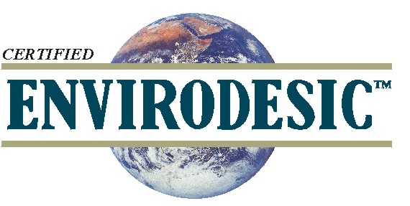
THE ENVIRODESIC™
CERTIFICATION PROGRAM FOR MAXIMUM INDOOR AIR QUALITY™ &
MINIMUM ENVIRONMENTAL IMPACT™
ENVIRODESIC™ TECHNOLOGY:
SUSTAINABLE BUILDINGS, PRODUCTS & SERVICES THAT MAKE MORE SENSE™
What Distinguishes Envirodesic™ Products?

Envirodesic™ Certification is distinctly different from that of other common green programs. It is based on the principle that one of the overriding purposes of ‘greening’ is to create a truly healthy indoor environment. Therefore no tradeoffs between sustainability and adverse health effects can be accepted.

Below are seven ways in which this program differs from other green programs that merely present a standard ‘bar’ to meet. As such, Envirodesic™ Certification is significantly more stringent than that of other certification or “green-product” programs:

- There is no standard checklist that indicates whether a product will or will not be Envirodesic™ certified. A systems approach is used in assessment of the products and the individuals and companies associated with them. Final judgment as to the suitability of any product for Envirodesic™ Certification rests with the principals of the Envirodesic™ Certification Program and on their experience and scientific integrity.
- Products that will be designated as “Envirodesic™ ” must be truly benign in terms of human health effects. This requires not just a lack of toxicity, but also compatibility with the requirements of environmentally hypersensitive individuals. This requires an absolute minimum of volatility, no use of perfumes and no components that are likely to sensitize any individual or trigger allergic or hypersensitivity reactions. The product must also be gentle on human skin and lungs.
- Such products must also be truly benign in terms of environmental impact. For example, cleaning products that will reach our waterways must be characterized by biodegradability under both aerobic and anaerobic conditions, lack of endocrine disruptor and other harmful or toxic chemicals and low aquatic toxicity.
- Such products must also go significantly further towards sustainability than before. For example, they may be produced from natural ingredients, combined with true environmental compatibility and acceptability for human health over many years of exposure. The product could theoretically be produced for hundreds of years without causing depletion or damage.
- The Envirodesic™ Certification Program selects only forefront technologies in any field. Such products must represent the cutting edge and a significant innovation compared to previous technologies. The program’s purpose is to lead the entire industry ever further in the direction of compatibility with environment, human health and sustainability.
- Envirodesic™ certified products must represent a significant contributing component of an indoor air quality program. Simply put, they must be become part of the solution rather than just becoming a smaller part of the problem. In so doing, they must also work effectively for their intended purpose, for example, cleaning compounds should clean exceptionally well.
- Envirodesic™ also assesses the integrity of the individuals and the companies that are involved. This includes the creation, production, distribution and marketing of products that may be certified. The principals involved must demonstrate sufficient flexibility to adjust product formulations wherever necessary as further feedback and testing is received, and to deal honestly and ethically with everyone about their product claims.

